# Prediction of Loan Application Status

## Group Members:

|  |
| --- |
| Aditya Som Choudhury  Techno India Main Saltlake  161300110620 |
|  |
| Amartya Paul  BP Poddar Institute of Management and Technology  161150110011 |
|  |
| Debaleen Das Spandan  Bengal College of Engineering and Technology  171250110041 |
|  |
| Palash Mondal  Techno India Saltlake  181300120082 |
|  |
| Shouvit Pradhan  Bengal College of Engineering and Technology  171250110093 |

# Contents

|  |  |  |
| --- | --- | --- |
| **Sl. No.** | **Topic** | **Page No.** |
|  | Acknowledgement | 1 |
|  | Project Objective | 2 |
|  | Project Scope | 3 |
|  | Data Description | 4-5 |
|  | Data Pre-Processing | 6-16 |
|  | Model Building | 17-37 |
|  | Test Dataset | 38 |
|  | Code | 39-74 |
|  | Future Scope of Improvements | 75 |
|  | Certificates | 76-80 |

# Acknowledgement

I take this opportunity to express my profound gratitude and deep regards to my faculty, **Prof. Arnab Chakraborty** for his exemplary guidance, monitoring and constant encouragement throughout the course of this project. The blessing, help and guidance given by him time to time shall carry me a long way in the journey of life on which I am about to embark.

I am obliged to my project team members for the valuable information provided by them in their respective fields. I am grateful for their cooperation during the period of my assignment.

Aditya Som Choudhury

Amartya Paul

Debaleen Das Spandan

Palash Mondal

Shouvit Pradhan

# Project Objective

In this project we have a shortened ‘Predict Loan Application Status’ Dataset from Kaggle. In this dataset, the target attribute is the loan status which is in binary. So, in this project we need to do binary classification based on the attributes present in our dataset and predict whether a loan application should be approved or not.

Our objective in this project is to study the given dataset of ‘Predict Loan Application Status’. We might need to pre-process the given dataset if we need to. Then, we would train 4 models viz. ‘KNN classifier model’, ‘Naive Bayes classifier model’, ‘Decision Tree classifier model’ and ‘Linear Regression classifier model’. After training the aforementioned models, we will need to find out the score, classification report, plot the Receiver Operating Characteristic graph and find out the Area Under Curve (AUC) for each of the models trained. Our next step would be to use the trained models to predict the outcomes using the given test dataset and compare the outcome of each model. We would then choose the best model based on the accuracy score and classification report.

Our methodology for solving the problems in the given project is described below:

* Load the required dataset.
* Study the dataset.
* Describe the dataset.
* Visualise the dataset.
* Find out if the dataset needs to be pre-processed.
  + It will be determined on the basis of whether the dataset has null values or outliers or any such discrepancy that might affect the output of the models to be trained.
* If the dataset is required to be pre-processed, take the necessary steps to pre-process the data.
* Find out the principal attributes for training.
* Split the given dataset for training and testing purpose.
* Fit the previously split train data in the aforementioned 4 models.
* Calculate the accuracy of the 4 models and find out the classification reports.
* Plot the necessary graphs.
* Use each trained model to predict the outcomes of the given test dataset.
* Choose the best model among the 4 trained models bases on the accuracy and classification reports.

# Project Scope

The broad scope of ‘Predict Loan Approval Status’ project is given below:

* The given dataset has attributes based on which the status of the approval of the loan application will be predicted.
* It is a useful project as the Classifier models can be used to quickly determine the loan approval status of large datasets.
* Various banking institution can use these models and modify them according to their needs to use in their loan approval status. This will reduce the manual labour and time spent on determining whether to approve a loan application.
* Customers who intend to take a loan can use these trained models to check whether their loan application will be approved or not. The trained models would be required to be implemented in a platform or interface easily accessible as well as with an easy GUI.
* The dataset given to us is a shortened form of the original dataset from Kaggle. So, the results might have some mismatch with the real-world applications. But that can be avoided if the models are trained accordingly.

# Data Description

**Source of the data:** Kaggle. The given dataset is a shortened version of the original dataset in Kaggle.

**Data Description:** The given train dataset has 100 rows and 13 columns.

|  |  |  |  |  |
| --- | --- | --- | --- | --- |
| **Columns** | **Attribute Name** | **Type** | **Description** | **Target Attribute** |
| Application Id | Application_ID | Non-categorical | An Id number for the specific loan application | No |
| Gender | Gender | Categorical | Gender of the applicant. (M/F) | No |
| Married | Married | Categorical | Marital status of the applicant. (Yes/No) | No |
| Dependent | Dependent | Categorical | Number of dependents on the applicant. (0, 1, 2, 3+) | No |
| Education | Education | Categorical | Education status of the applicant. (Graduate/Not Graduate) | No |
| Self-Employed | Self_Employed | Categorical | Whether the applicant is self-employed or not. (Yes/No) | No |
| Applicant Income | ApplicantIncome | Non-categorical | Income amount of the applicant | No |
| Co-applicant Income | CoapplicantIncome | Non-categorical | Income amount of the co-applicant | No |
| Loan Amount | LoanAmount | Non-categorical | Amount of loan applied for. | No |
| Loan Amount Term | Loan_Amount_Term | Non-categorical | Term period for applied loan amount | No |
| Credit History | Credit_History | Categorical | Credit history of the applicant. (1/0) | No |
| Property Area | Property_Area | Categorical | Location of property of the applicant. (Urban/Semiurban/Rural) | No |
| Loan Status | Loan_Status | Categorical | Loan approval status of the loan application. (Y/N) | Yes |

Table 1: Data Description

The following table shows the 5 number statistics of the given dataset:

|  |  |  |  |  |
| --- | --- | --- | --- | --- |
|  | **ApplicantIncome** | **CoapplicantIncome** | **LoanAmount** | **Loan_Amount_Term** |
| **Mean** | 4122.83000 | 1700.550000 | 134.600000 | 341.130000 |
| **Standard deviation** | 2258.89434 | 1947.668891 | 62.103856 | 61.022211 |
| **Minimum** | 1000.00000 | 0.000000 | 17.000000 | 60.000000 |
| **25%** | 2636.00000 | 0.000000 | 100.000000 | 360.000000 |
| **50%** | 3598.00000 | 1558.500000 | 120.000000 | 360.000000 |
| **75%** | 4710.00000 | 2394.500000 | 152.750000 | 360.000000 |
| **Maximum** | 12841.00000 | 10968.000000 | 349.000000 | 480.000000 |

Table 2: 5 number statistics of the given dataset

Now we will pre-process the data. The methodology followed is given below:

* Checking for null values.
  + If null values are present, we will fill them or drop the row containing the null value based on the dataset.
* Checking for outliers.
  + If outliers are present, they will either be removed or replaced by following a suitable method depending on the dataset.

# Data Pre-processing

As the given dataset had Categorical and Non-categorical data mixed, we converted the categorical data into non-categorical data accordingly. We converted the binary categories into 0 and 1. We converted the other categorical attributes into suitable numerical values. The following table shows the conversion record:

|  |  |  |
| --- | --- | --- |
| **Non-Numeric to Numeric Change table** | | |
| Column | Initial Value | Replaced Value |
| Married | No | 0 |
| Yes | 1 |
| Gender | M | 0 |
| F | 1 |
| Education | Not Graduate | 0 |
| Graduate | 1 |
| Self-Employed | No | 0 |
| Yes | 1 |
| Loan Status | N | 0 |
| Y | 1 |
| Dependents | ‘0’ | 0 |
| ‘1’ | 1 |
| ‘2’ | 2 |
| ‘3+’ | 3 |
| Property Area | Rural | 0 |
| Semiurban | 1 |
| Urban | 2 |

Table 3: Categorical to Numerical change in values

We searched for null values in our dataset and formed the following table:

|  |  |
| --- | --- |
| **Column Name** | **Count of Null Value** |
| Application Id | 0 |
| Gender | 1 |
| Married | 0 |
| Dependents | 0 |
| Education | 0 |
| Self-Employed | 6 |
| Applicant Income | 0 |
| Co-applicant Income | 0 |
| Loan Amount | 5 |
| Loan Amount Term | 5 |
| Credit History | 8 |
| Property Area | 0 |
| Loan Status | 0 |

Table 4: Count of Null values

To visualise the null values, we made a heatmap plot using seaborn library function heatmap. The heatmap plot is given below:

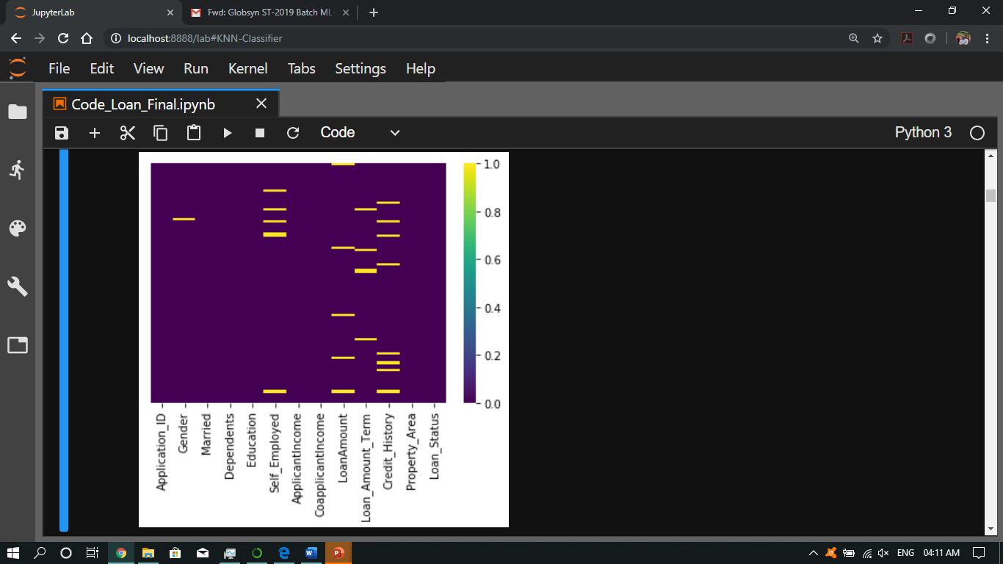

Fig 1: Heatmap of the given Data

The heatmap shows that the dataset has null values

To remove the null values, we had the following methodology:

* filling Null values in 'Credit_History' with 0 (as stated in the dataset description from source)
* filling Null values in binary columns with mode value. This was applied in columns ‘Self_Employed’ and ‘Gender’.
* filling Null values with mean +- std in non-binary columns. This was applied in column ‘LoanAmount’ and “Loan_Amount_Term’.

After removing the null values, the following heatmap was obtained:

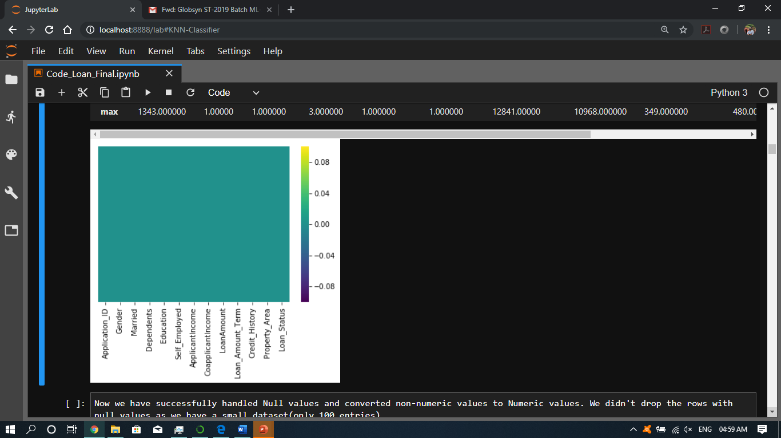

Fig 2: Heatmap implying absence of null values.

Now we have successfully handled Null values and converted non-numeric values to Numeric values. We didn't drop the rows with null values as we have a small dataset (only 100 entries).

So, we are moving on to find if there are any outliers in our data and find the correlations of different attributes to our target i.e. 'Loan_Status' column in the dataset.

The following table gives the correlation value of each attribute with our target attribute i.e. ‘Loan_Status’:

|  |  |
| --- | --- |
| **Columns** | **Correlation value** |
| Gender | -0.09335200560186736 |
| Education | 0.013861413315217981 |
| Self_Employed | 0.04212465653604544 |
| ApplicantIncome | -0.1196673096146476 |
| CoapplicantIncome | -0.03110315854904195 |
| LoanAmount | -0.18017272662780226 |
| Loan_Amount_Term | 0.11608628153827855 |
| Credit_History | 0.5306941097826289 |
| Property_Area | 0.24889474150088223 |
| Married | 0.12792979689405484 |
| Dependents | 0.0057840889995565475 |

Table 5: Correlation values with Target Attribute

Outliers are extreme values that deviate from other observations on data, they may indicate a variability in a measurement, experimental errors or a novelty. In other words, an outlier is an observation that diverges from an overall pattern on a sample.

Most common causes of outliers on a data set:

* Data entry errors (human errors)
* Measurement errors (instrument errors)
* Experimental errors (data extraction or experiment planning/executing errors)
* Intentional (dummy outliers made to test detection methods)
* Data processing errors (data manipulation or data set unintended mutations)
* Sampling errors (extracting or mixing data from wrong or various sources)
* Natural (not an error, novelties in data)

We plot distribution graph and boxplot to visualise the outliers. The plots are given below:

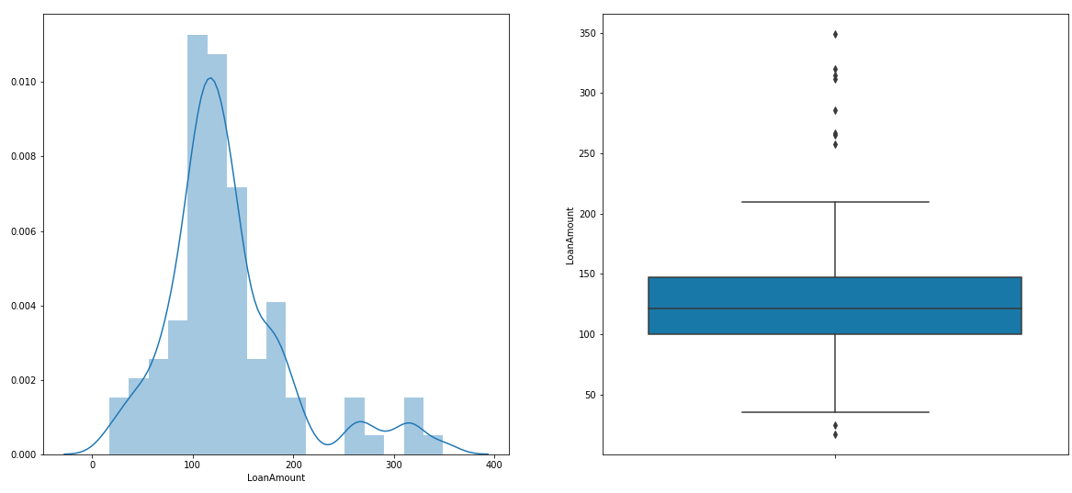

Distribution plot and boxplot of Loan Amount showing possible outliers

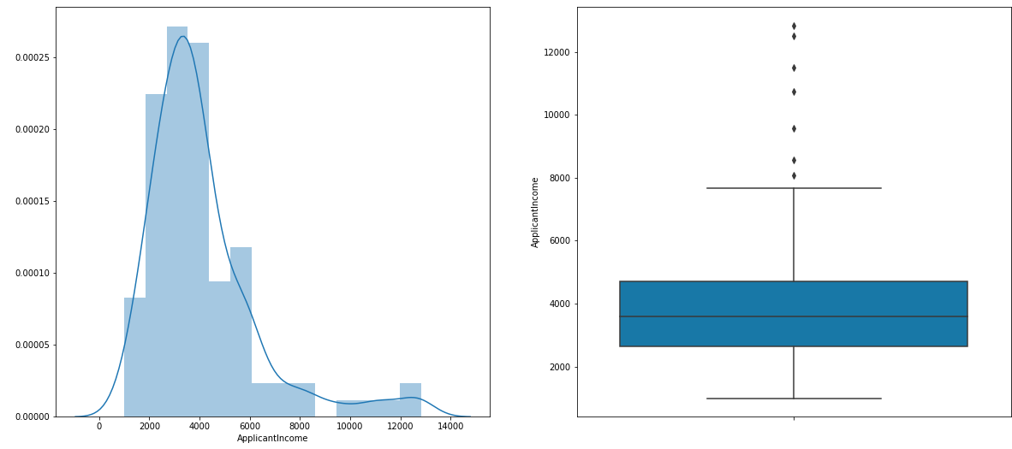

Distribution plot and boxplot of Applicant Income showing possible outliers

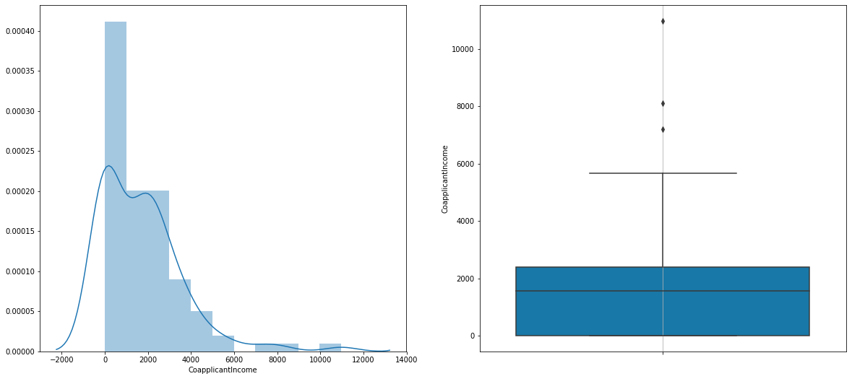

Distribution plot and boxplot of Co-applicant Income showing possible outliers

Fig 3: Distribution plot and boxplot of 3 attributes viz.

‘LoanAmount’, ‘ApplicantIncome’ and ‘CoapplicantIncome’

From the distribution plots and boxplots, we can see that there are possible outliers in the columns 'LoanAmount', 'ApplicantIncome' and 'CoapplicantIncome'.

We have not checked for outliers in the columns viz. 'Gender', 'Married', 'Education', 'Self_Employed', and 'Credit_History' as they are columns having values in binaries and also initially, they had non-numeric values. We have not checked for outliers in the columns viz. 'Dependents' and 'Property_Area' as they are columns having values that were initially non-numeric. We have not checked for outliers in the column 'Loan_Amount_Term' as the mean and MAD values of this column are in the range 3*(mean or MAD). So, this method won't have any effect on the data of the column 'Loan_Amount_Term'.

Now, we had to handle the outliers. We handled the outliers using non-parametric statistics method. We used Median Absolute Deviation or MAD to handle the outliers. In this method, data outside the range 3 * mad is excluded and replaced with median of the data.

After handling the data, we replot the same distribution and boxplot but this time using the modified data. We obtain the following plots:

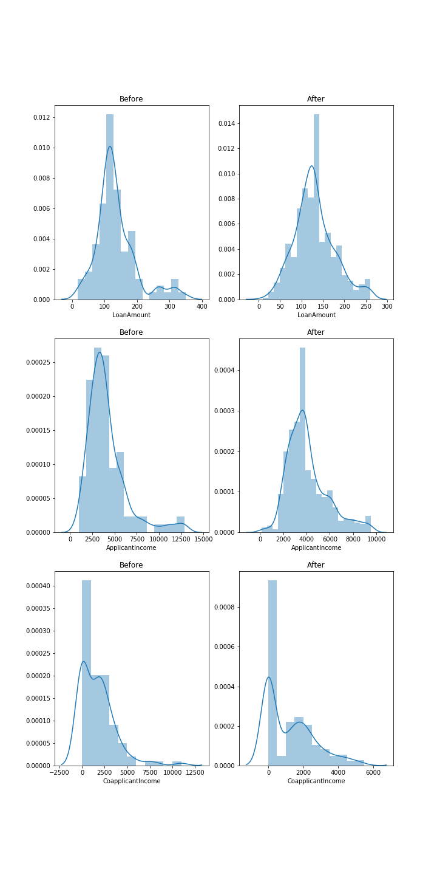

Fig 4

Fig 4: Comparison between distribution plot and boxplot of 3 attributes before and after handling outliers

The following plots show the comparison of the 3 attributes viz. ‘LoanAmount’, ‘ApplicantIncome’ and ‘CoapplicantIncome’ before and after handling outliers:

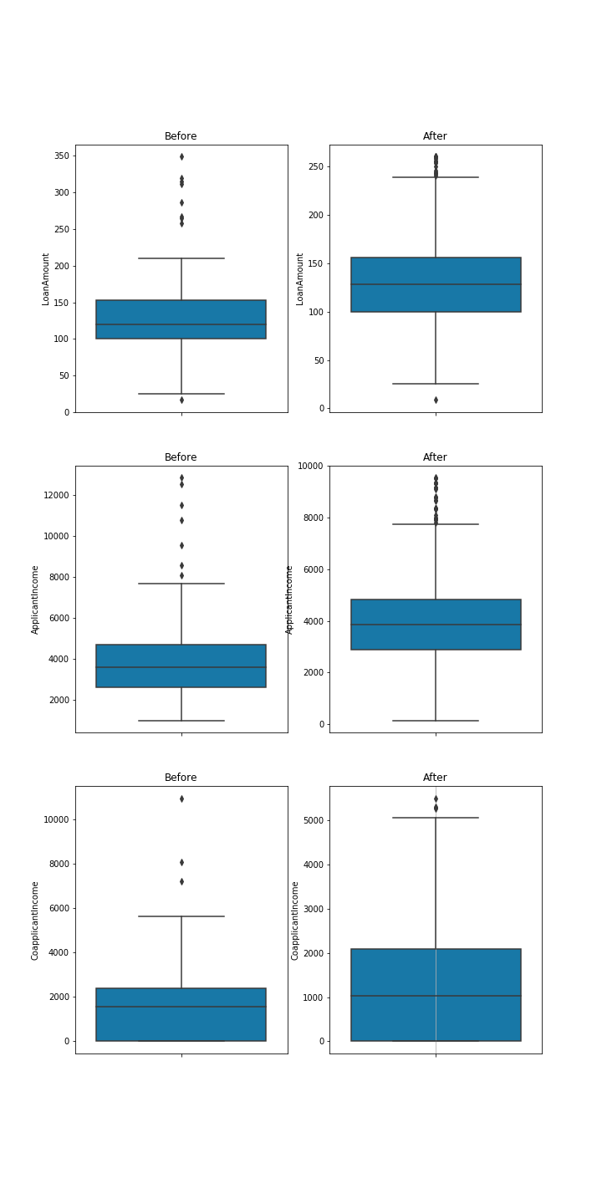

Fig 5: Comparison boxplot of 3 attributes

From the distribution plots and boxplots shown above, we can see that a lot of outliers have been handled. Now we will use this data to train a Random Forest Classifier model. We will be training a Random Forest Classifier model to determine the principal attributes in the dataset.

We will now visualise other attributes with respect to our target column i.e. 'Loan_Status'. We have used bar plot to visualise other attributes against the data in 'LoanAmount' column and using our target attribute i.e. 'Loan_Status' as hue.

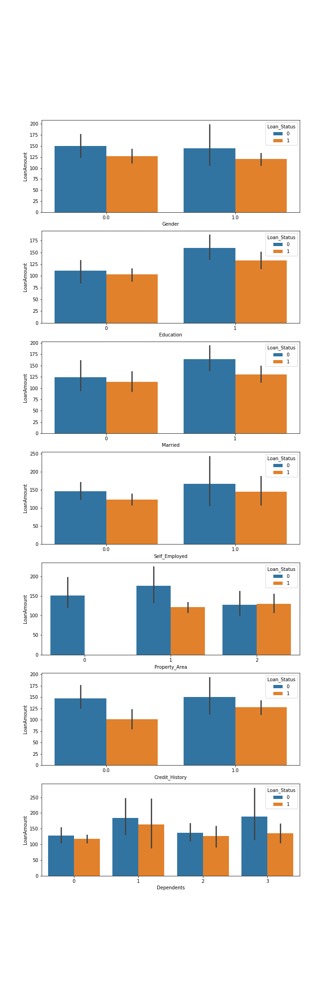





Fig 6: Visualising other attributes

From the above graphs one interesting thing that can be noted is that no loans are approved i.e. 'Loan_Status' = 1 for 'Property_Area' value 'Rural' i.e. 'Property_Area' = 0. All the loan requests for 'Property_Area' value 'Rural' i.e. 'Property_Area' = 0 are denied. We will now train a Random Forest Classifier Model.

A random forest is a meta estimator that fits a number of decision tree classifiers on various sub-samples of the dataset and uses averaging to improve the predictive accuracy and control over-fitting. The sub-sample size is always the same as the original input sample size but the samples are drawn with replacement unless specified otherwise.

We have used Random Forest Classifier to determine the principal attributes as this classifier has a built-in feature importance function.

# Model Building

### Splitting data for training and testing purpose

We split the given train dataset into two parts for training and testing purpose. The split ratio we used is 0.75 which indicates we used 75% data for training purpose and 25% data for testing purpose. We will be using the same split ratio for all the models trained.

### Random Forest Classifier Model

The object description of the Random Forest Classifier used is given below:

|  |  |
| --- | --- |
| **Object Name** | RandomForestClassifier |
| **Parameters** | **Value** |
| bootstrap | True |
| class_weight | None |
| criterion | 'gini' |
| max_depth | None |
| max_features | 'auto' |
| max_leaf_nodes | None |
| min_impurity_decrease | 0.0 |
| min_impurity_split | None |
| min_samples_leaf | 1 |
| min_samples_split | 2 |
| min_weight_fraction_leaf | 0.0 |
| n_estimators | 100 |
| n_jobs | 2 |
| oob_score | False |
| random_state | 0 |
| verbose | 1 |
| warm_start | False |

Table 6: Object Parameter Table for Random Forest Classifier

Now we created a confusion matrix to view the actual and predicted test results. Given below is the confusion matrix:

|  |  |  |
| --- | --- | --- |
| **Predicted Loan_Status** | **0** | **1** |
| **Actual Loan_Status** |
| **0** | 7 | 2 |
| **1** | 2 | 7 |

Table 7: Confusion matrix of Random Forest Classifier

We trained the Random Forest Classifier Model although it was not our goal, to find out the feature importance of the given attributes and choose the principal attributes for training our goal models. Random Forest Classifier has an inbuilt feature importance function that gives the value of importance of each attribute and helps in determining the target attribute.

The following table consists of the feature importance obtained from our Random Forest Classifier:

|  |  |
| --- | --- |
| **Attribute** | **Feature Importance** |
| 'Gender' | 0.017472373045798174 |
| 'Married' | 0.032310146537087026 |
| 'Dependents' | 0.06274092539838881 |
| 'Education' | 0.01727880655895561 |
| 'Self_Employed' | 0.02014039877295202 |
| 'ApplicantIncome' | 0.1746432652177679 |
| 'CoapplicantIncome' | 0.11756790122516193 |
| 'LoanAmount' | 0.12842666389187288 |
| 'Loan_Amount_Term' | 0.060373745068559366 |
| 'Credit_History' | 0.22613376236476954 |
| ‘Property_Area' | 0.14291201191868688 |

Table 8: Feature importance table obtained from Random Forest Classifier

As we can see from the calculated feature importance values, the attributes viz. 'ApplicantIncome', 'CoapplicantIncome', 'LoanAmount', 'Credit_History' and 'Property_Area' have higher values compared to other attributes. So, we will select these 5 attributes as our principal attribute to train our required models.

One interesting thing to notice here is that although 'Married' attribute had a high correlation value with our target attribute, 'Loan_Status', the feature importance of 'Married' attribute is lower.

The following table shows the selected principle attributes and their respective feature importance:

|  |  |
| --- | --- |
| **Attribute** | **Feature Importance** |
| 'ApplicantIncome' | 0.1746432652177679 |
| 'CoapplicantIncome' | 0.11756790122516193 |
| 'LoanAmount' | 0.12842666389187288 |
| 'Credit_History' | 0.22613376236476954 |
| ‘Property_Area' | 0.14291201191868688 |

Table 9: Feature importance of selected principal attributes

NOTE: These values will change with each run. But these 5 attributes will always have the highest feature importance if trained as above.

Now we will modify the dataset to include only the selected principal attributes. We made a copy of the initial dataset and then dropped the non-principal attributes viz. ‘Gender’, ‘Married’, 'Dependents', 'Self_Employed', 'Loan_Amount_Term'. Now we obtained a final dataset which we will use for training purpose of our required models.

Given below is the description of the final dataset obtained:

|  |  |  |  |  |  |
| --- | --- | --- | --- | --- | --- |
|  | **ApplicantIncome** | **CoapplicantIncome** | **LoanAmount** | **Credit_History** | **Property_Area** |
| **Type** | Non-categorical | Non-categorical | Non-categorical | Categorical | Categorical |
| **unique** | NaN | NaN | NaN | 2 | 3 |
| **Mean** | 3636.720000 | 1606.455000 | 120.480000 | NaN | NaN |
| **Standard deviation** | 1325.607679 | 1707.964583 | 38.476145 | NaN | NaN |
| **Minimum** | 1000.000000 | 0.000000 | 17.000000 | NaN | NaN |
| **25%** | 2636.00000 | 0.000000 | 100.000000 | NaN | NaN |
| **50%** | 3597.000000 | 1542.250000 | 120.000000 | NaN | NaN |
| **75%** | 4197.500000 | 2341.500000 | 138.000000 | NaN | NaN |
| **Maximum** | 7660.000000 | 8106.000000 | 210.000000 | NaN | NaN |

Table 10: 5 Description of the final data obtained

Please Note, we have not included our target attribute ‘Loan_Status’ in the data description.

Now we will be training our required models. Our project goal requires us to train specific 4 classifier models viz.

1. KNN classifier

2. Naive Bayes Classifier

3. Decision Tree Classifier

and

4. Regression (As the target attribute is binary, we will be using Logistic Regression Classifier)

We will be using the final dataset obtained after pre-processing the given train dataset to train our required models.

### KNN Classifier

k-NN can be used for both classification and regression predictive problems. However, it is more widely used in classification problems in the industry. In pattern recognition, the k-nearest neighbors algorithm (k-NN) is a non-parametric method used for classification and regression. In both cases, the input consists of the k closest training examples in the feature space. The output depends on whether k-NN is used for classification or regression.

In k-NN classification, the output is a class membership. An object is classified by a plurality vote of its neighbors, with the object being assigned to the class most common among its k nearest neighbors (k is a positive integer, typically small). For e.g. if k = 1, then the object is simply assigned to the class of that single nearest neighbor. k-NN is a type of instance-based learning, or lazy learning, where the function is only approximated locally and all computation is deferred until classification. The k-NN algorithm is among the simplest of all machine learning algorithms. The neighbors are taken from a set of objects for which the class (for k-NN classification) or the object property value (for k-NN regression) is known. This can be thought of as the training set for the algorithm, though no explicit training step is required.

An example of k-NN classification:

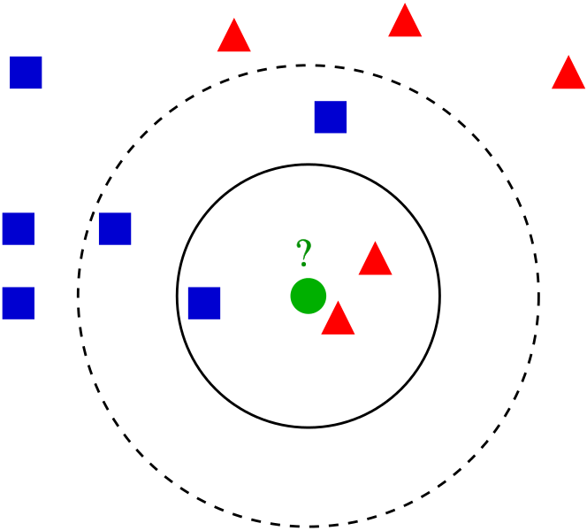

Example of k-NN classification. The test sample (green dot) should be classified either to blue squares or to red triangles. If k = 3 (solid line circle) it is assigned to the red triangles because there are 2 triangles and only 1 square inside the inner circle. If k = 5 (dashed line circle) it is assigned to the blue squares (3 squares vs. 2 triangles inside the outer circle).

We used a GridSearchCV object to find the best optimum value of k. Our test results gave the value of k = 5. The object description of the k-NN Classifier used is given below:

|  |  |
| --- | --- |
| **Object Name** | KNeighborsClassifier |
| **Parameters** | **Value** |
| algorithm | 'auto' |
| leaf_size | 30 |
| metric | 'minkowski' |
| metric_params | None |
| n_neighbors | 3 |
| p | 2 |
| weights | 'uniform' |

Table 11: Object Parameter Table for k-NN Classifier

Now we created a confusion matrix to view the actual and predicted test results. Given below is the confusion matrix:

|  |  |  |
| --- | --- | --- |
| **Predicted Loan_Status** | **0** | **1** |
| **Actual Loan_Status** |
| **0** | 1 | 8 |
| **1** | 2 | 13 |

Table 12: Confusion matrix of k-NN Classifier

Now we plot the Receiver Operating Characteristics (ROC) curve for our trained k-NN model. The ROC curve is given below:

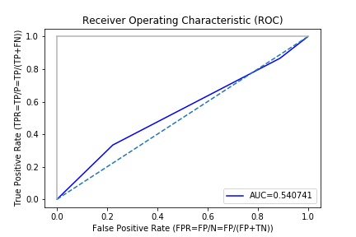

Fig 7: ROC curve of k-NN classifier model

From the Receiver Operating Characteristic (ROC) graph, we find the Area Under Curve (AUC) for our KNN classifier model is 0.540741

AUC value of KNN = 0.540741

Now we will be preparing the classification report of our k-NN model.

|  |  |  |  |  |  |
| --- | --- | --- | --- | --- | --- |
| **Classification Report of k-NN classifier model** | | | | | |
| **Accuracy** | | | 0.625 | | |
|  | **precision** | **recall** | | **f1-score** | **support** |
| **0** | 0.33 | 0.11 | | 0.17 | 9 |
| **1** | 0.62 | 0.87 | | 0.72 | 15 |

Table 13: Classification Report table of k-NN classifier

### Naive Bayes Classifier

A Naive Bayes classifier is a probabilistic machine learning model that’s used for classification task. The crux of the classifier is based on the Bayes theorem. The fundamental Naive Bayes assumption is that each feature makes an:

* independent
* equal

contribution to the outcome. The assumptions made by Naive Bayes are not generally correct in real-world situations. In-fact, the independence assumption is never correct but often works well in practice.

**Bayes Theorem:**

Bayes’ Theorem finds the probability of an event occurring given the probability of another event that has already occurred. Bayes’ theorem is stated mathematically as the following equation:

$$P\left(\left.A\right|B\right)=\frac{P\left(A\right)P\left(\left.B\right|A\right)}{P\left(B\right)}$$

where A and B are events and P(B) is the probability of occurrence of event B.

Basically, we are trying to find probability of event A, given the event B is true. Event B is also termed as evidence.

P(A) is the priori of A (the prior probability, i.e. Probability of event before evidence is seen). The evidence is an attribute value of an unknown instance (here, it is event B).

P(A|B) is a posteriori probability of B, i.e. probability of event after evidence is seen.

The class-data relation from the Bayes Theorem can be obtained as follows:

$$P\left(\left.Class\right|Data\right)=\frac{P\left(Class\right)P\left(\left.Data\right|Class\right)}{P\left(Data\right)}$$

Where,

* P(Class|Data) = Posterior
* P(Class) = Prior
* P(Data|Class) = Likelihood
* P(Data) = Marginal Probability

In other words, it can be written as:

$$Posterior=\frac{Prior*Likelihood}{Marginal Probability}$$

In application, we do not need to calculate the Marginal Probability for classification. We only need to calculate the numerator of the posterior for classification.

Types of Naive Bayes Classifier:

*Multinomial Naive Bayes:*

This is mostly used for document classification problem, i.e. whether a document belongs to the category of sports, politics, technology etc. The features/predictors used by the classifier are the frequency of the words present in the document.

*Bernoulli Naive Bayes:*

This is similar to the multinomial Naive Bayes but the predictors are Boolean variables. The parameters that we use to predict the class variable take up only values yes or no, for example if a word occurs in the text or not.

*Gaussian Naive Bayes:*

When the predictors take up a continuous value and are not discrete, we assume that these values are sampled from a gaussian distribution.

The object description of the Naive Bayes used is given below:

|  |  |
| --- | --- |
| **Object Name** | GaussianNB |
| **Parameters** | **Value** |
| priors | None |
| var_smoothing | 1e-09 |

Table 14: Object Parameter Table for Gaussian Naive Bayes Classifier

Now we created a confusion matrix to view the actual and predicted test results. Given below is the confusion matrix:

|  |  |  |
| --- | --- | --- |
| **Predicted Loan_Status** | **0** | **1** |
| **Actual Loan_Status** |
| **0** | 7 | 2 |
| **1** | 0 | 15 |

Table 15: Confusion matrix of Gaussian Naive Bayes Classifier

Now we plot the Receiver Operating Characteristics (ROC) curve for our trained Gaussian Naive Bayes model. The ROC curve is given below:

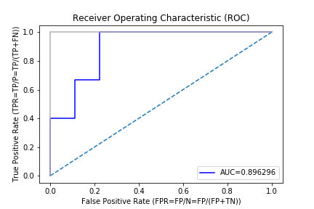

Fig 8: ROC curve of Gaussian Naive Bayes classifier model

From the Receiver Operating Characteristic (ROC) graph, we find the Area Under Curve (AUC) for our Gaussian Naive Bayes model is 0.896296.

AUC value of Gaussian Naive Bayes = 0.896296.

Now we will be preparing the classification report of our Gaussian Naive Bayes model.

|  |  |  |  |  |  |
| --- | --- | --- | --- | --- | --- |
| **Classification Report of Gaussian Naive Bayes model** | | | | | |
| **Accuracy** | | | 0.91667 | | |
|  | **precision** | **recall** | | **f1-score** | **support** |
| **0** | 1.0 | 0.78 | | 0.88 | 9 |
| **1** | 0.88 | 1.0 | | 0.94 | 15 |

Table 16: Classification Report table of Gaussian Naive Bayes classifier

### Decision Tree

Decision tree is the most powerful and popular tool for classification and prediction. A Decision tree is a flowchart like tree structure, where each internal node denotes a test on an attribute, each branch represents an outcome of the test, and each leaf node (terminal node) holds a class label. A tree has many analogies in real life, and turns out that it has influenced a wide area of machine learning, covering both classification and regression. In decision analysis, a decision tree can be used to visually and explicitly represent decisions and decision making. As the name goes, it uses a tree-like model of decisions. Though a commonly used tool in data mining for deriving a strategy to reach a particular goal, it’s also widely used in machine learning.

The object description of the Decision Tree Classifier used is given below:

|  |  |
| --- | --- |
| **Object Name** | DecisionTreeClassifier |
| **Parameters** | **Value** |
| class_weight | None |
| criterion | 'gini' |
| max_depth | None |
| max_features | None |
| max_leaf_nodes | None |
| min_impurity_decrease | 0.0 |
| min_impurity_split | None |
| min_samples_leaf | 1 |
| min_samples_split | 2 |
| min_weight_fraction_leaf | 0.0 |
| presort | False |
| random_state | None |
| splitter | 'best' |

Table 17: Object Parameter Table for Decision Tree Classifier

Now we created a confusion matrix to view the actual and predicted test results. Given below is the confusion matrix:

|  |  |  |
| --- | --- | --- |
| **Predicted Loan_Status** | **0** | **1** |
| **Actual Loan_Status** |
| **0** | 6 | 3 |
| **1** | 2 | 13 |

Table 18: Confusion matrix of Decision Tree Classifier

Now we plot the Receiver Operating Characteristics (ROC) curve for our trained Decision Tree model. The ROC curve is given below:

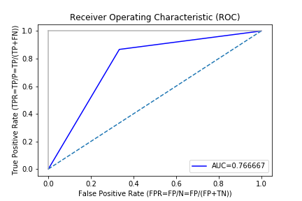

Fig 9: ROC curve of Decision Tree model

From the Receiver Operating Characteristic (ROC) graph, we find the Area Under Curve (AUC) for our Decision Tree classifier model is 0.766667.

AUC value of Decision Tree = 0.766667.

Now we will be preparing the classification report of our Decision Tree

The decision tree prepared by the trained model is given in the next page.

|  |  |  |  |  |  |
| --- | --- | --- | --- | --- | --- |
| **Classification Report of Decision Tree classifier model** | | | | | |
| **Accuracy** | | | 0.7916666666666666 | | |
|  | **precision** | **recall** | | **f1-score** | **support** |
| **0** | 0.75 | 0.67 | | 0.71 | 9 |
| **1** | 0.81 | 0.87 | | 0.84 | 15 |

Table 19: Classification Report table of Decision Tree classifier



Fig 10: Decision Tree

### Logistic Regression

Logistic Regression (also called Logit Regression) is commonly used to estimate the probability that an instance belongs to a particular class (e.g., what is the probability that this email is spam?). If the estimated probability is greater than 50%, then the model predicts that the instance belongs to that class (called the positive class, labelled “1”), or else it predicts that it does not (i.e., it belongs to the negative class, labelled “0”). This makes it a binary classifier.

Binary logistic regression major assumptions:

* The dependent variable should be dichotomous in nature (e.g., presence vs. absent).
* There should be no outliers in the data, which can be assessed by converting the continuous predictors to standardized scores, and removing values below -3.29 or greater than 3.29.
* There should be no high correlations (multicollinearity) among the predictors. This can be assessed by a correlation matrix among the predictors. Some authors suggest that as long correlation coefficients among independent variables are less than 0.90 the assumption is met.

At the centre of the logistic regression analysis is the task estimating the log odds of an event. Mathematically, logistic regression estimates a multiple linear regression function defined as:

logit(p)

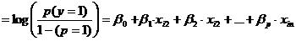

for i = 1…...n.

The object description of the Logistic Regression Classifier used is given below:

|  |  |
| --- | --- |
| **Object Name** | LogisticRegression |
| **Parameters** | **Value** |
| C=1.0 | C=1.0 |
| solver | 'lbfgs' |
| class_weight | None |
| dual | False |
| fit_intercept | True |
| intercept_scaling | 1 |
| max_iter | 100 |
| multi_class | 'warn' |
| n_jobs | None |
| penalty | 'l2' |
| random_state=None | None |
| tol | 0.0001 |
| verbose | 0 |
| warm_start | False |

Table 20: Object Parameter Table for Logistic Regression Classifier

The intercept of the trained model is: -0.62505495.

The coefficients of the model are given in the table below:

|  |  |
| --- | --- |
| **Attribute** | **Coefficient** |
| ApplicantIncome | -1.90032183e-04 |
| CoapplicantIncome | -6.94385392e-05 |
| LoanAmount | 1.41847856e-03 |
| Credit_History | 1.50926139e+00 |
| Property_Area | 7.27142583e-01 |

Table 21: Coefficients of attributes if the trained Logistic Regression Model

Now we created a confusion matrix to view the actual and predicted test results. Given below is the confusion matrix:

|  |  |  |
| --- | --- | --- |
| **Predicted Loan_Status** | **0** | **1** |
| **Actual Loan_Status** |
| **0** | 6 | 3 |
| **1** | 1 | 14 |

Table 22: Confusion matrix of Logistic Regression Classifier

Now we plot the Receiver Operating Characteristics (ROC) curve for our trained Logistic Regression model. The ROC curve is given below:

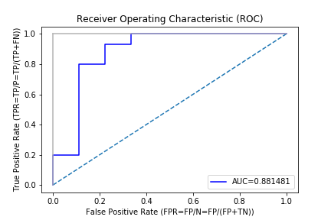

Fig 11: ROC curve of Logistic Regression model

From the Receiver Operating Characteristic (ROC) graph, we find the Area Under Curve (AUC) for our Logistic Regression model is 0.881481.

AUC value of Logistic Regression = 0.881481.

Now we will be preparing the classification report of our Logistic Regression model.

|  |  |  |  |  |  |
| --- | --- | --- | --- | --- | --- |
| **Classification Report of Logistic Regression Classifier model** | | | | | |
| **Accuracy** | | | 0.881481 | | |
|  | **precision** | **recall** | | **f1-score** | **support** |
| **0** | 0.86 | 0.67 | | 0.75 | 9 |
| **1** | 0.82 | 0.93 | | 0.87 | 15 |
| **Logistic Regression RMSE** | | | | 0.4082 | |
| **Logistic Regression R-squared** | | | | 0.8333 | |

Table 23: Classification Report table of Logistic Regression classifier

### Comparison of the Models trained

We trained 4 models using the 4 algorithms viz.

1. k-Nearest Neighbour
2. Gaussian Naive Bayes
3. Decision Tree and
4. Logistic Regression

The 4 models had different accuracy. The comparison of the accuracies of the models are given below:

|  |  |
| --- | --- |
| **Model** | **Accuracy %** |
| k-Nearest Neighbour | 58.334 |
| Gaussian Naive Bayes | 91.667 |
| Decision Tree | 79.167 |
| Logistic Regression | 83.334 |

Table 24: Accuracy Comparison table

The following bar graph shows the accuracy comparison in graphical way:

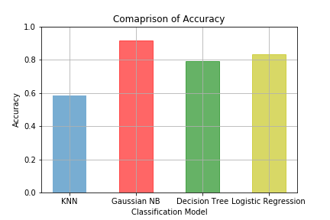

Fig 12: Comparison of accuracy of the 4 different models trained

Thus, from the above comparison we can see that Gaussian Naive Bayes classifier has the highest accuracy. So, our selected model is Gaussian Naive Bayes Classifier Model.

We also trained the above-mentioned classifiers without removing outliers from the dataset. The following table shows the comparison of accuracy of the classifiers trained:

|  |  |  |
| --- | --- | --- |
| **Classifier Model Trained** | **Data Used** | **Accuracy %** |
| k-NN | Removing outliers, without standardizing | 58.334 |
| k-NN | Removing outliers, with standardizing | 56.000 |
| k-NN | With outliers, without standardizing | 55.556 |
| K-NN | With outliers, with standardizing | 60.714 |
| Gaussian Naive Bayes | With outliers | 76.923 |
| Gaussian Naive Bayes | Removing outliers | 91.667 |
| Logistic Regression | With outliers | 68.000 |
| Logistic Regression | Removing outliers | 83.334 |
| Decision Tree | With outliers | 80.000 |
| Decision Tree | Removing outliers | 79.167 |

Table 25: Comparison of different models trained with different version of the dataset

We choose the following classifier models as they were most accurate and in accordance with each other:

|  |  |  |
| --- | --- | --- |
| **Classifier Model Trained** | **Data Used** | **Accuracy %** |
| k-NN | Removing outliers, without standardizing | 58.334 |
| Gaussian Naive Bayes | Removing outliers | 91.667 |
| Logistic Regression | Removing outliers | 83.334 |
| Decision Tree | Removing outliers | 79.167 |

Table 26: Selected classifier models and dataset used

# Test Dataset

### Testing the given Test Dataset

We were given a test dataset for this loan approval problem. We pre-process the given test dataset in similar way we pre-processed our train dataset. The methodology followed is given below:

* Change the categorical values to numeric values using same process we used during changing values in our train dataset.
* Checking for null values.
  + If null values are present, we will fill them or drop the row containing the null value based on the dataset.
* Checking for outliers.
  + If outliers are present, they will either be removed or replaced by following a suitable method depending on the dataset.

N.B.: We handled the outliers using non-parametric statistics method. We used Median Absolute Deviation or MAD to handle the outliers. In this method, data outside the range 3 * mad is excluded and replaced with median of the data. This is the same procedure we used to handle outliers in our train dataset.

After pre-processing of the test dataset had been done, we retrained the models with 100% of the train dataset given and used those trained models to predict the outcome for each input in the test dataset. There was a total of 514 inputs in the test dataset.

The outcomes obtained are tabulated as below:

|  |  |  |
| --- | --- | --- |
| **Classifier Models** | **Outcomes** | |
| **0 (No)** | **1 (Yes)** |
| Logistic Regression​ | 165 | 349 |
| Gaussian Naive Bayes | 247 | 267 |
| Decision Tree | 259 | 255 |
| K-Nearest Neighbour | 142 | 372 |

Table 27: Outcomes of 4 different classifier models on the test dataset.

As, the accuracy of the Gaussian Naive Bayes Classifier Model is the highest, we accept the outcome provided by the Gaussian Naive Bayes Classifier.

# Codes

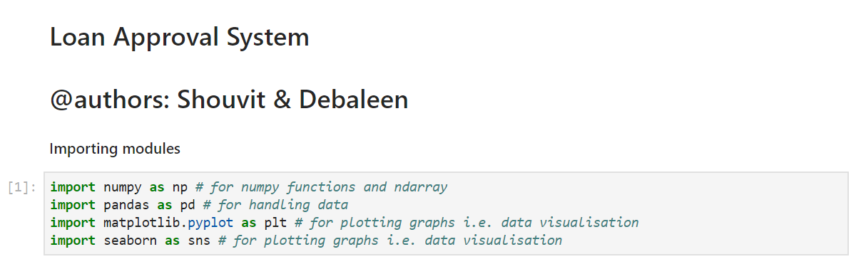

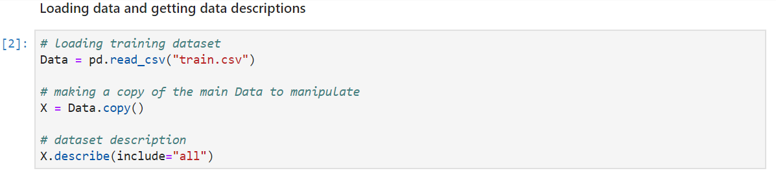

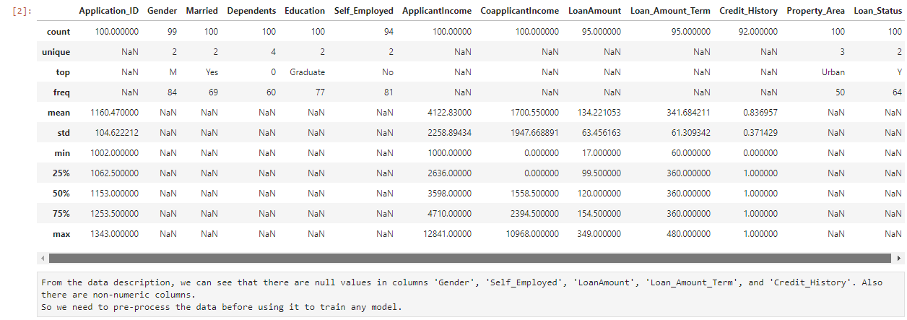

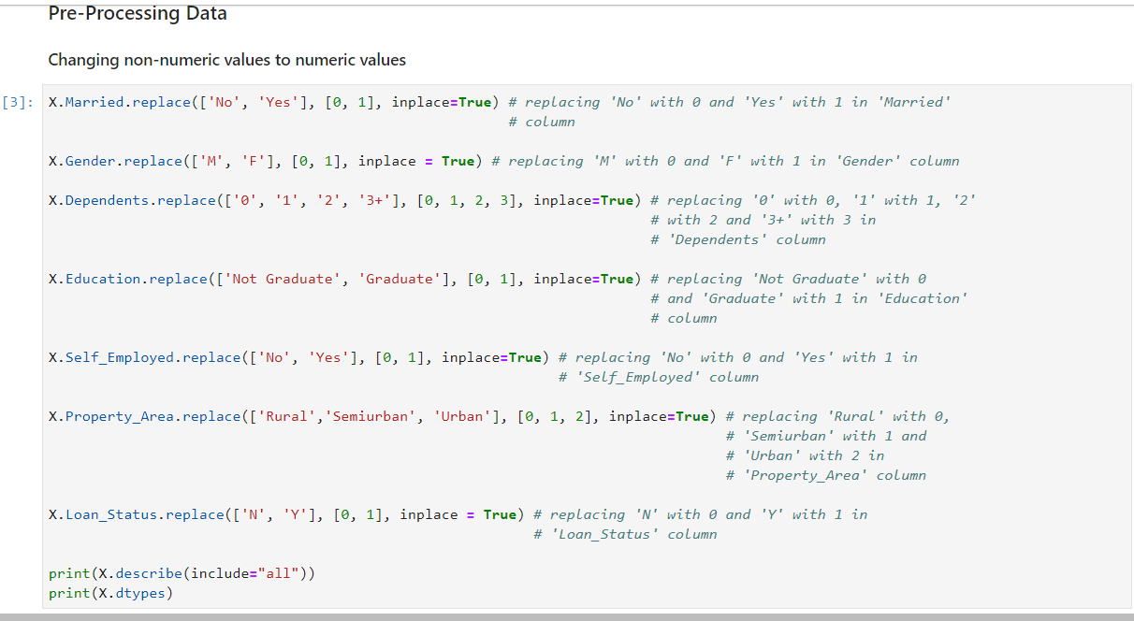

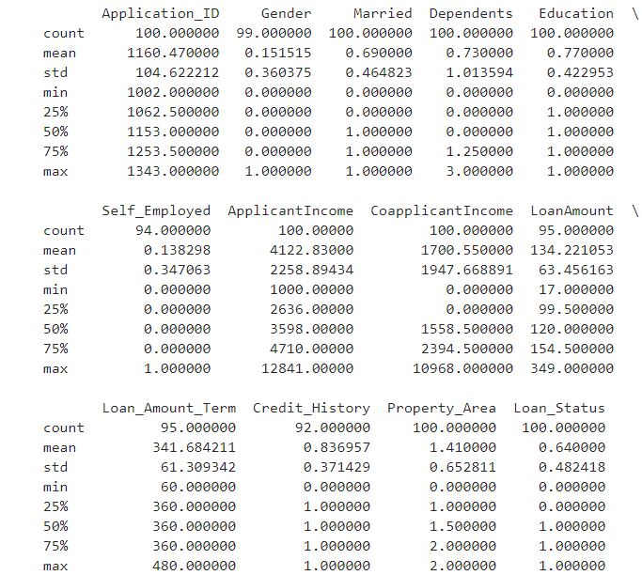

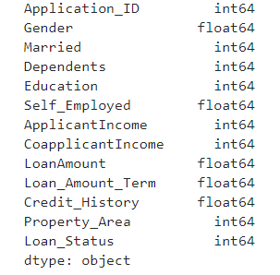

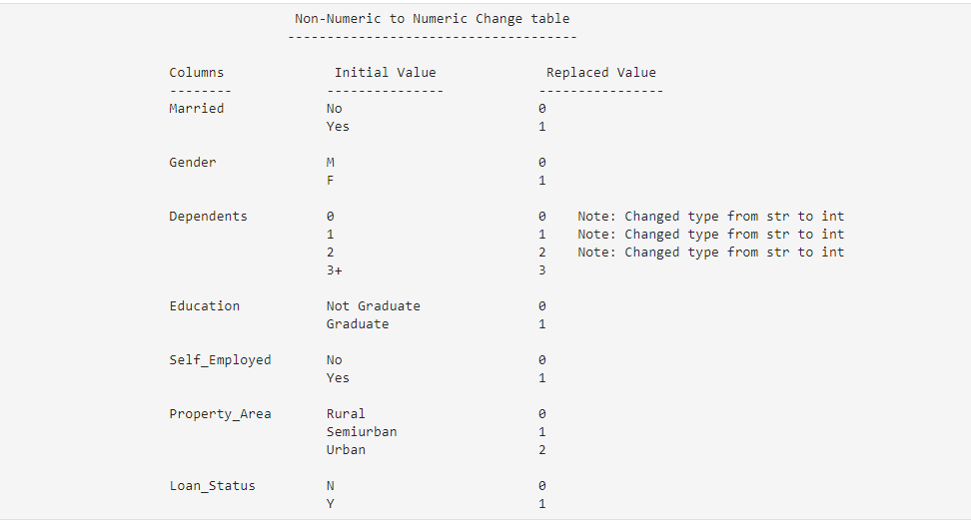

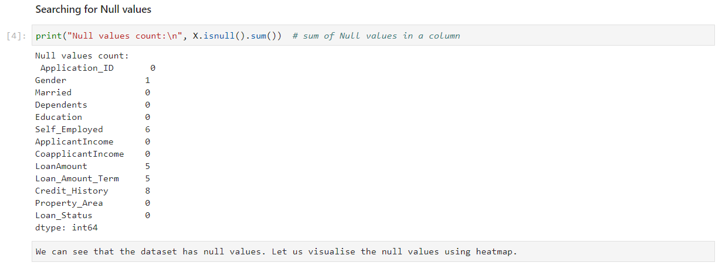

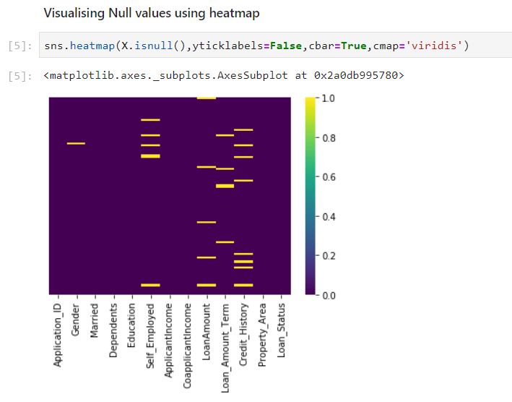

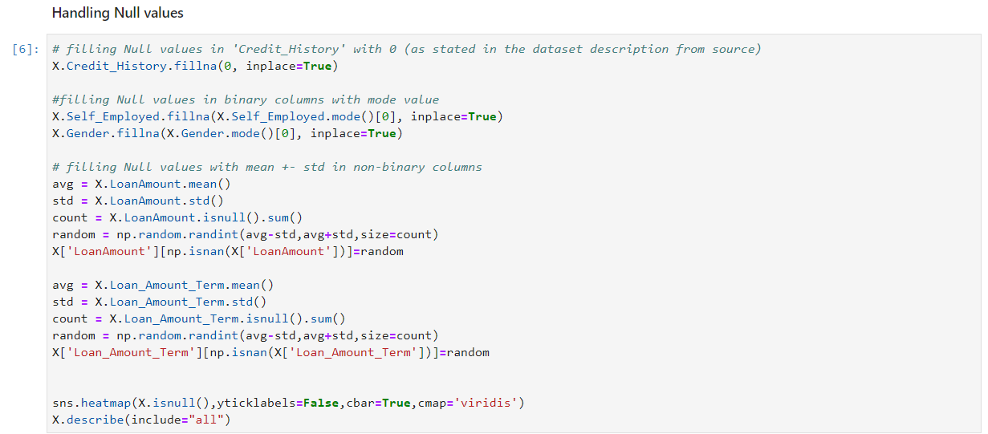

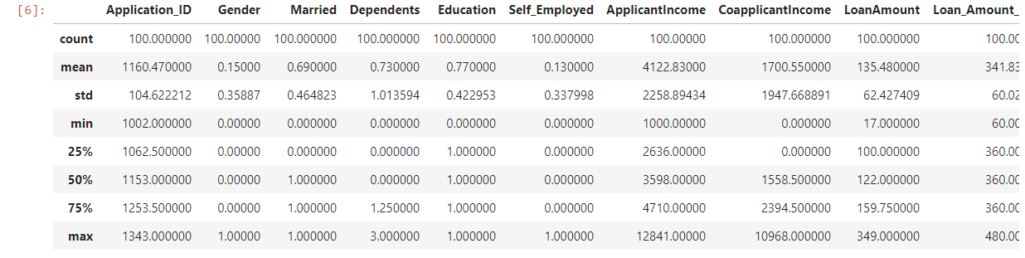

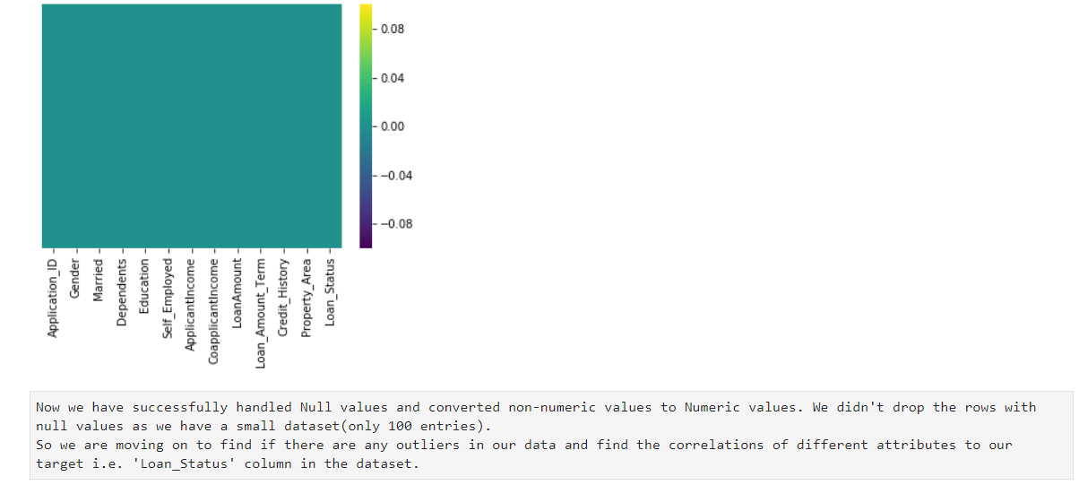

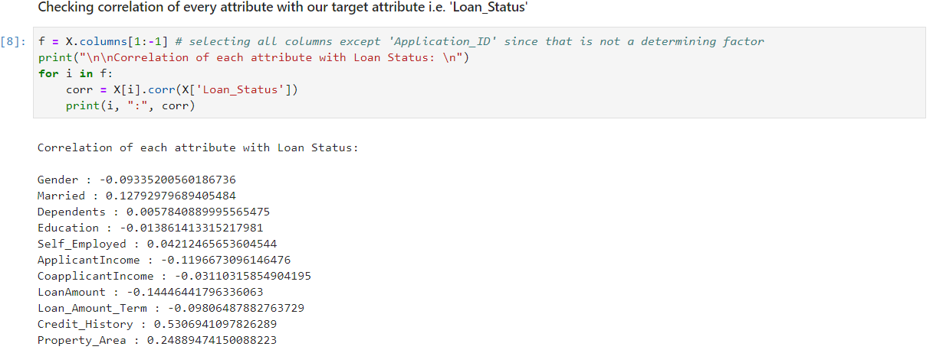

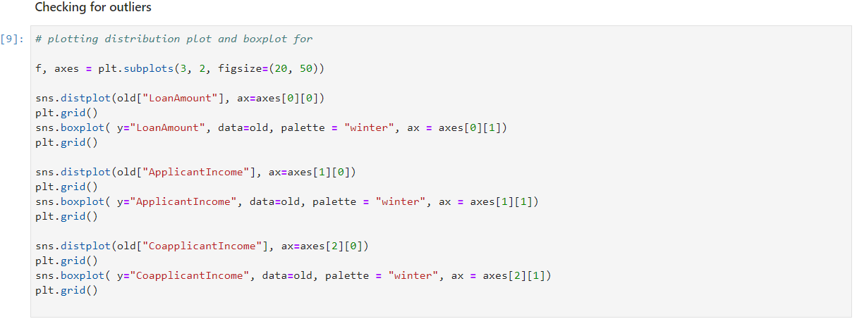

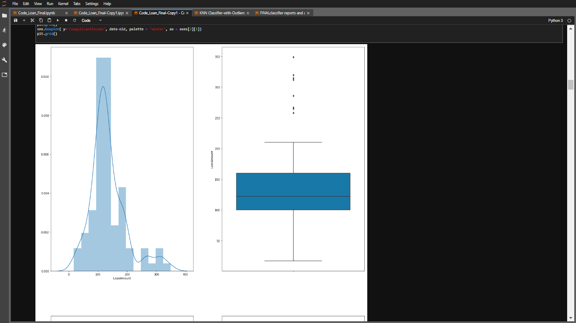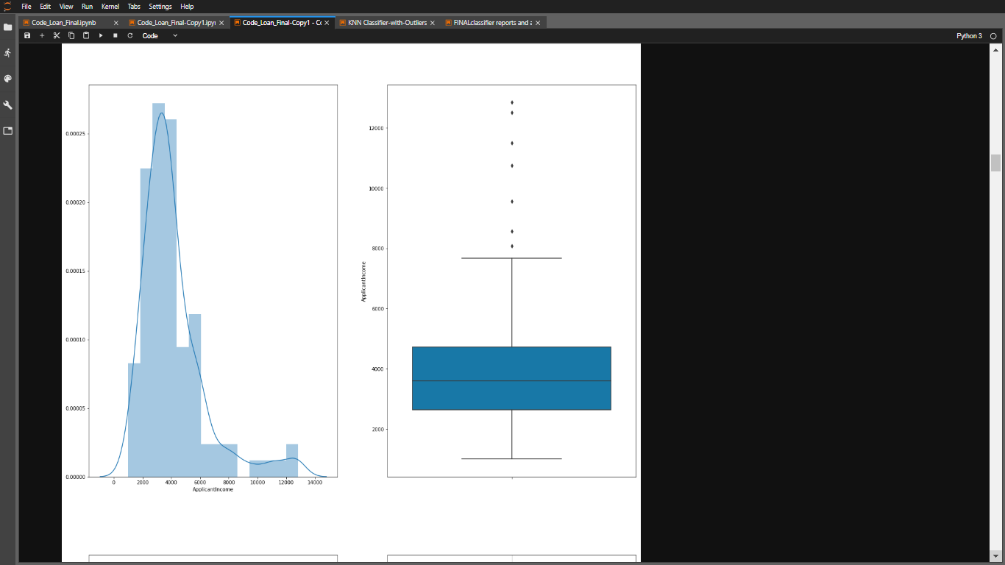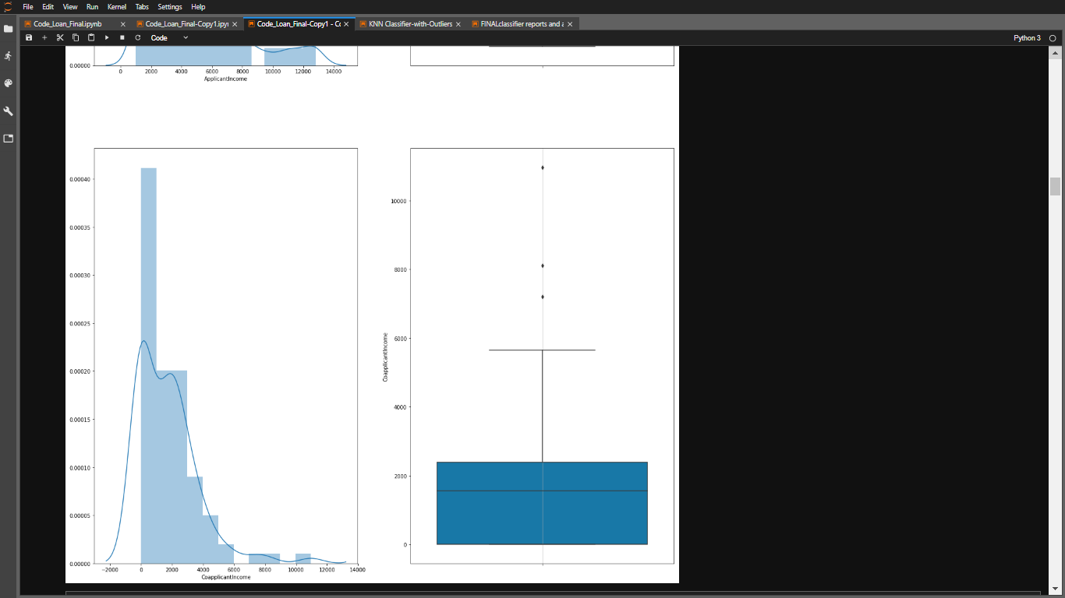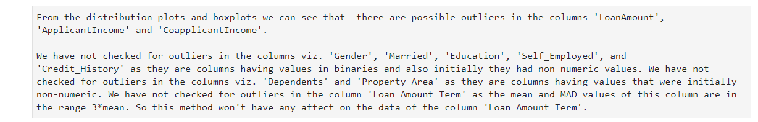

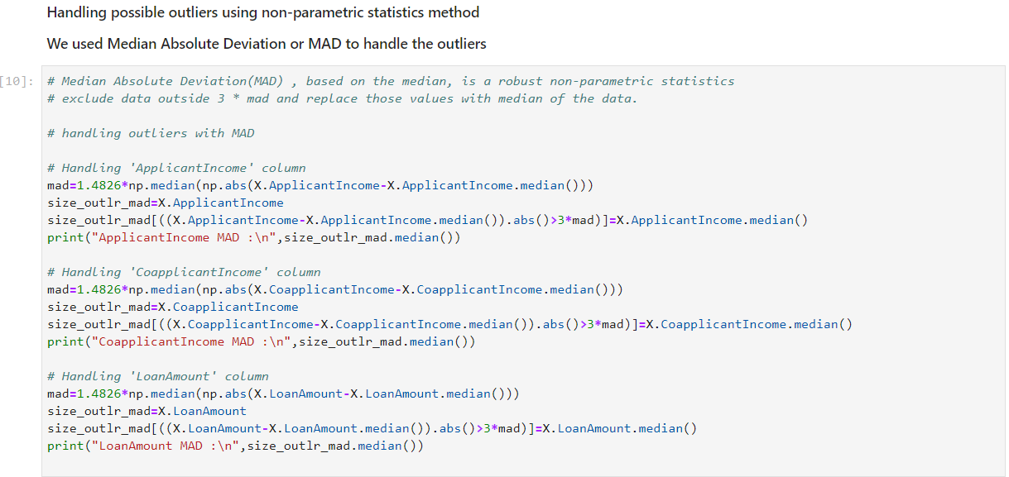

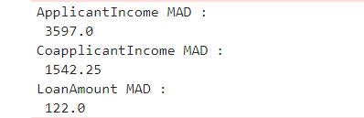

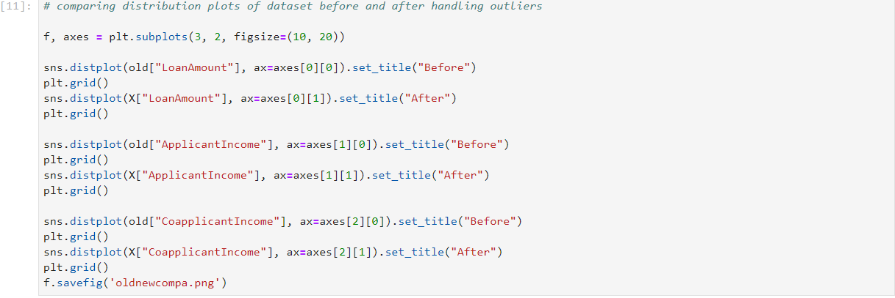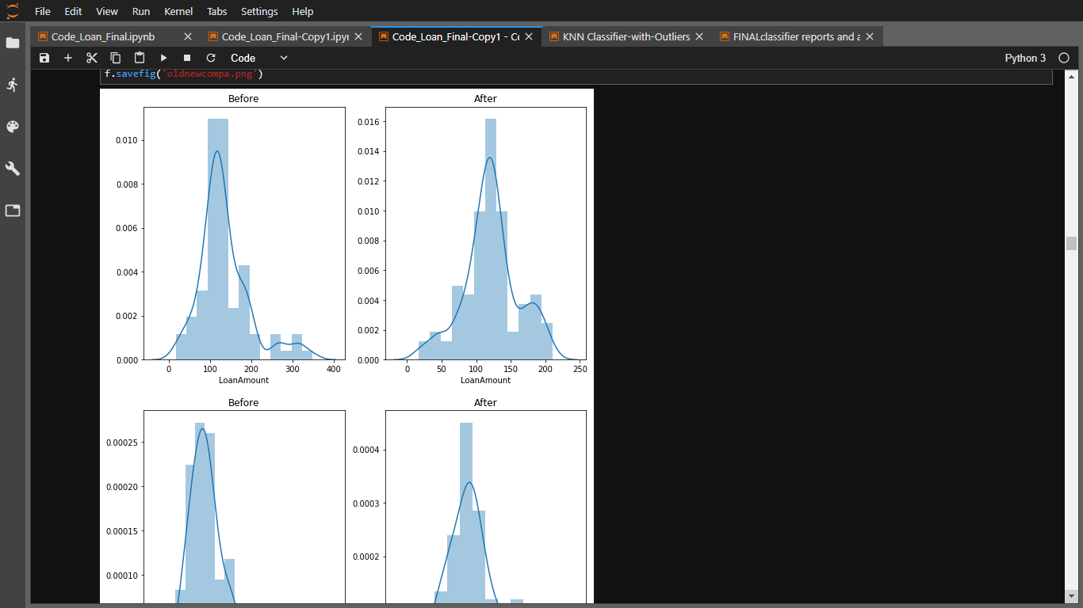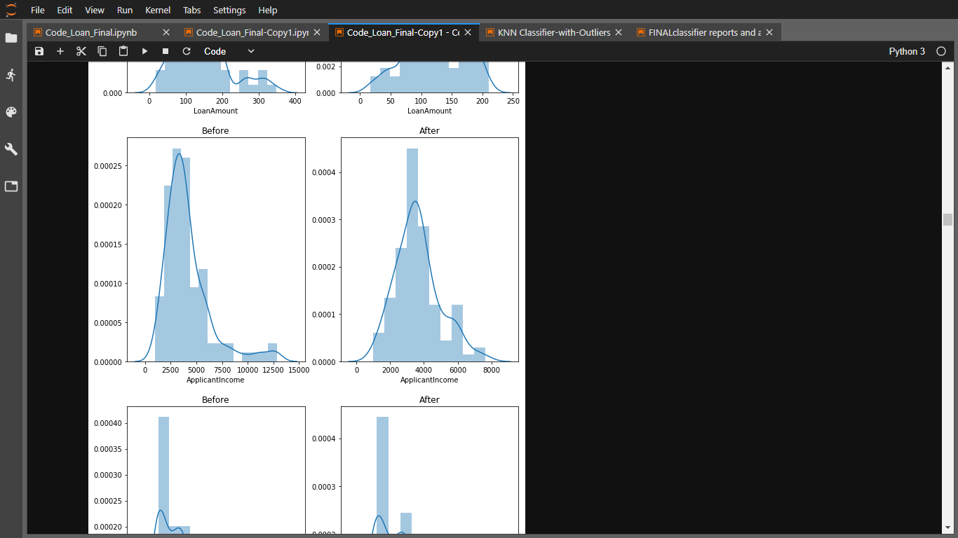

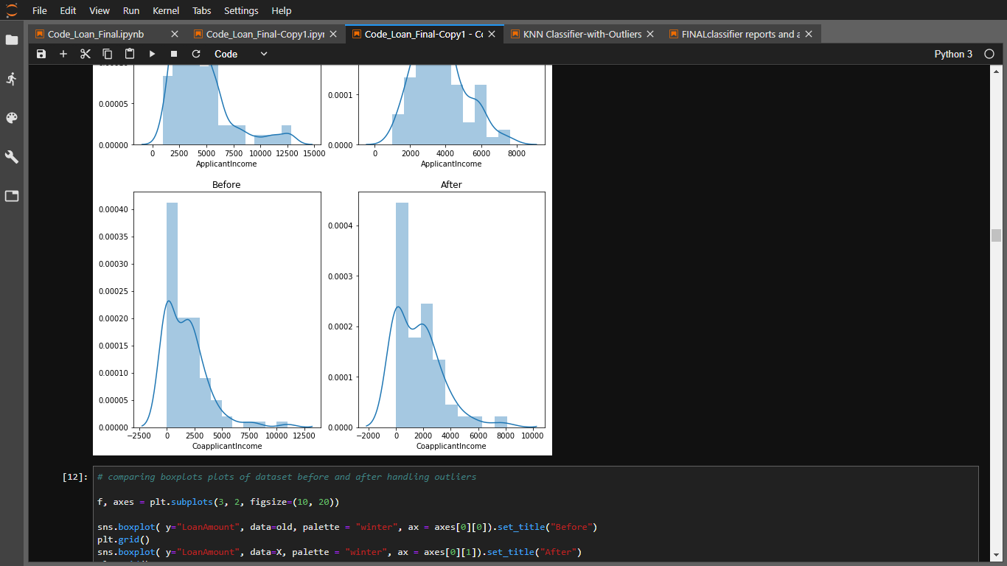

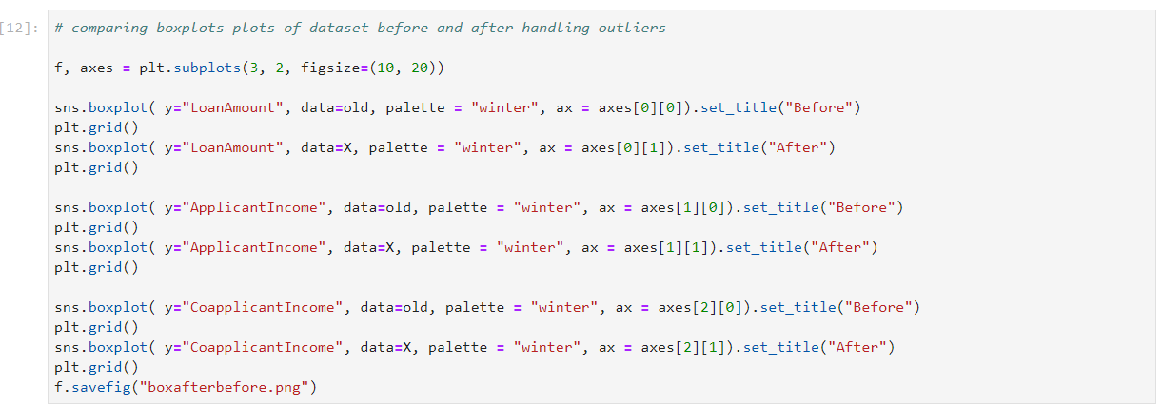

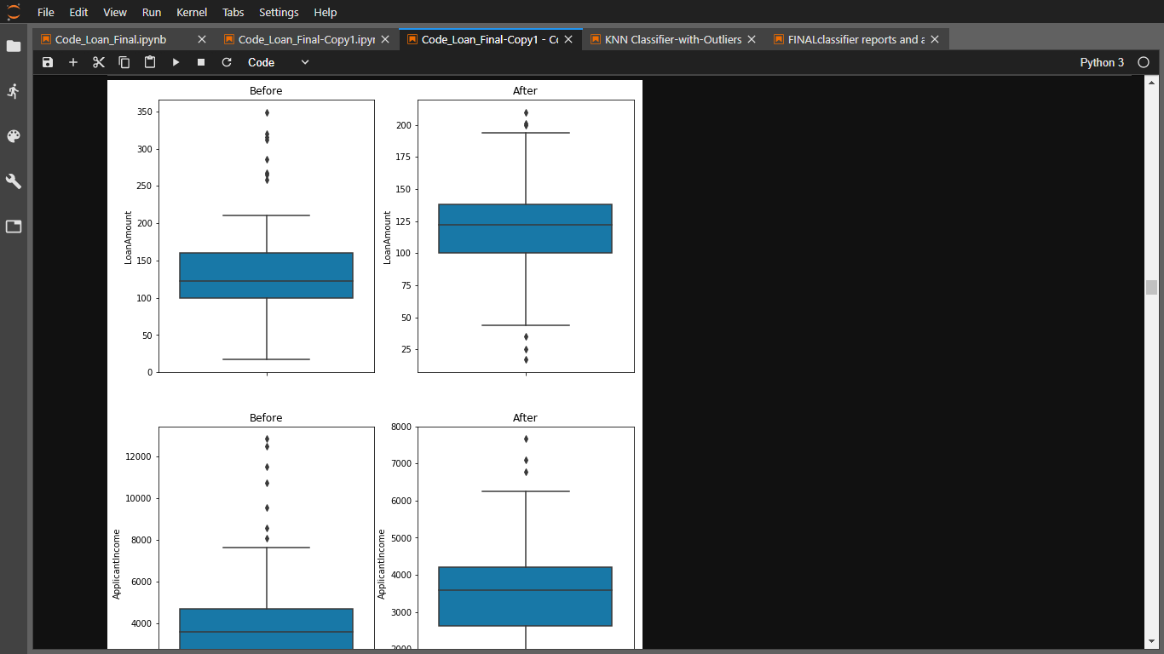

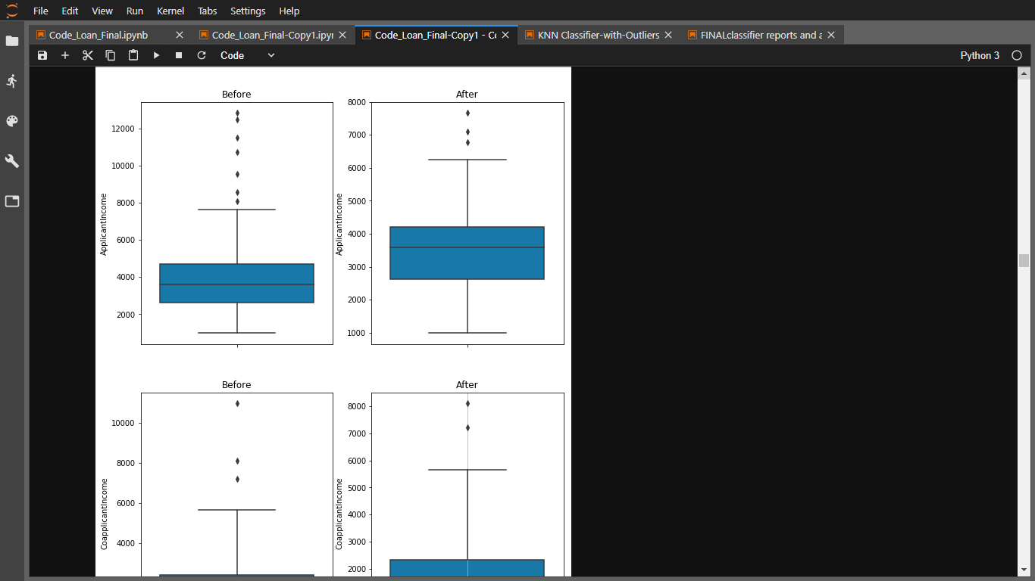

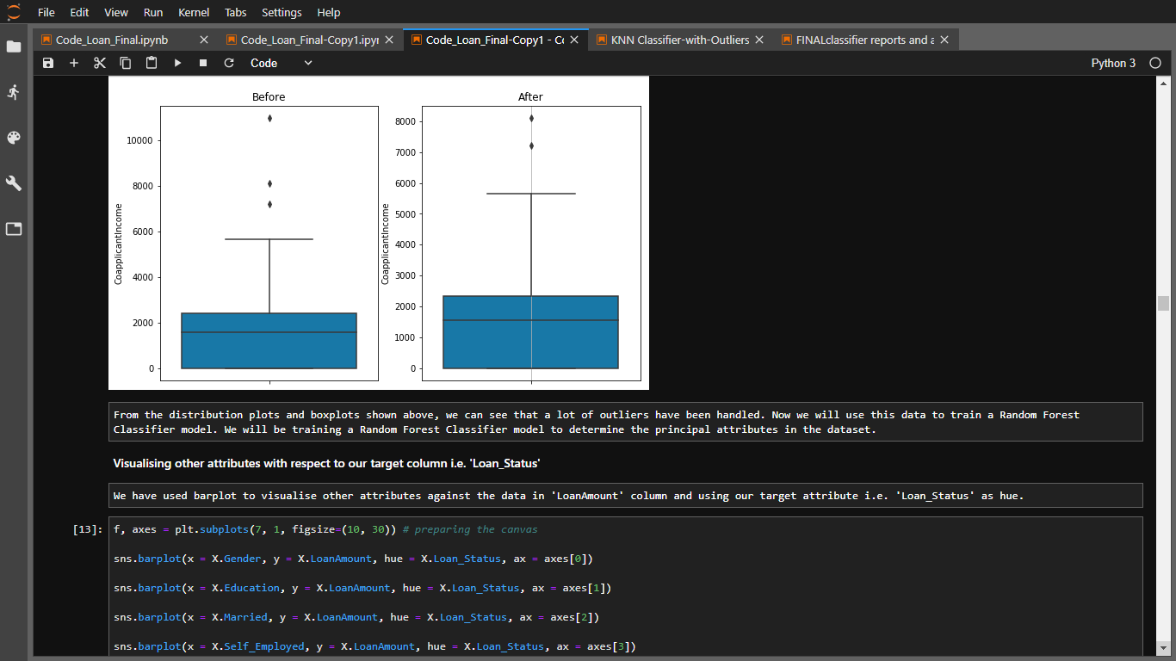

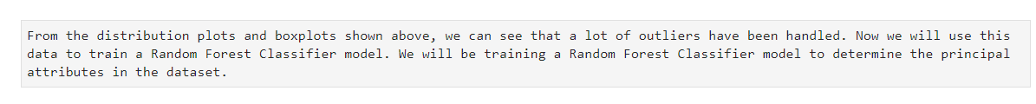

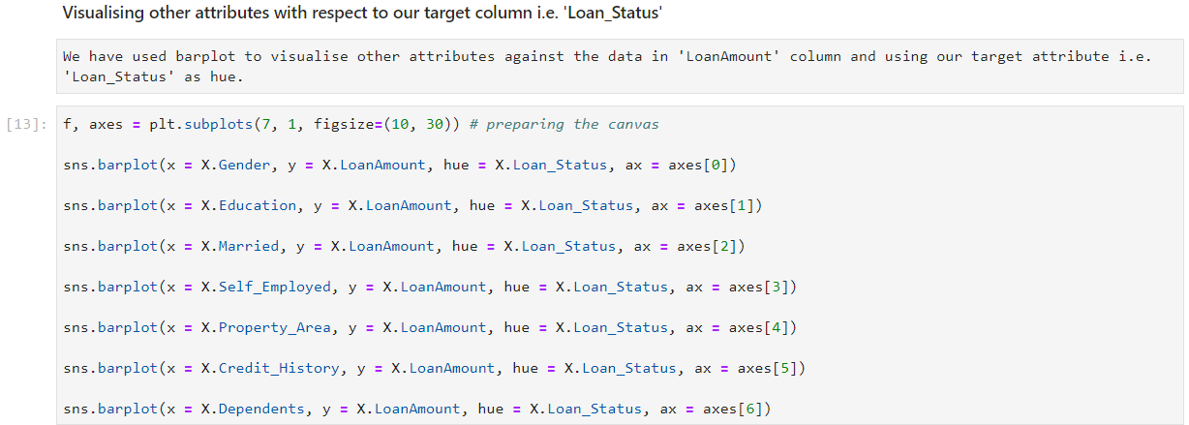

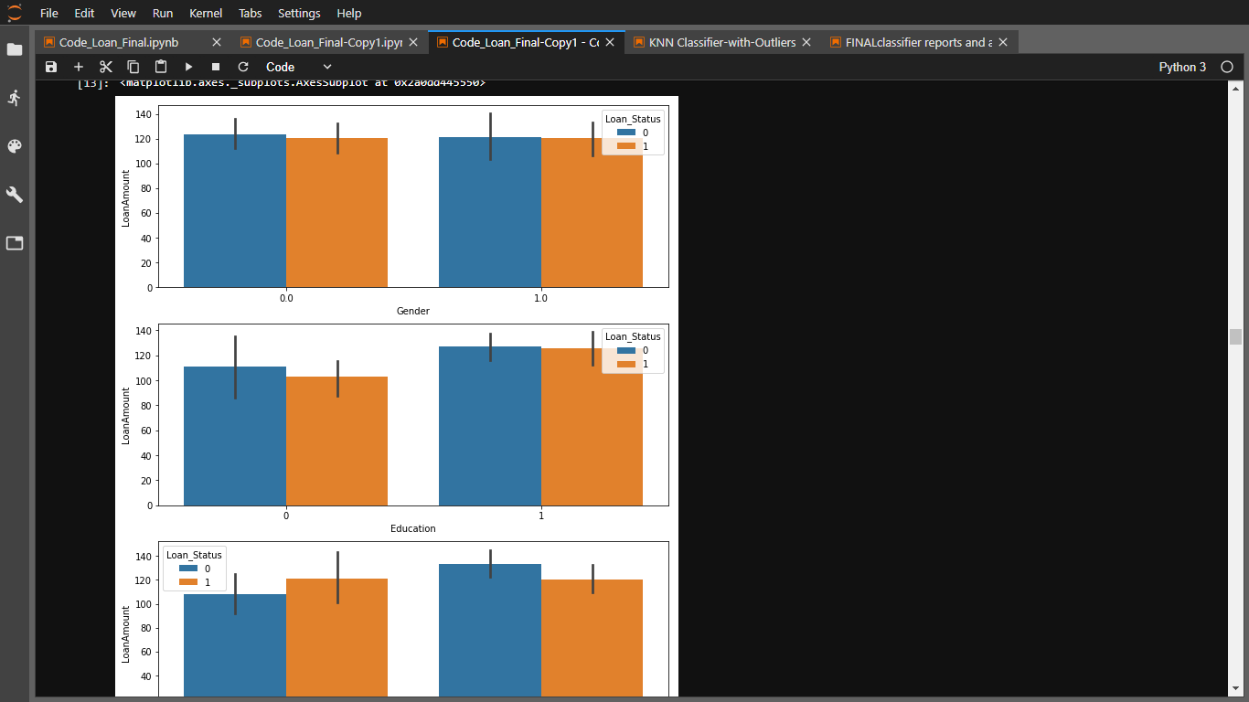

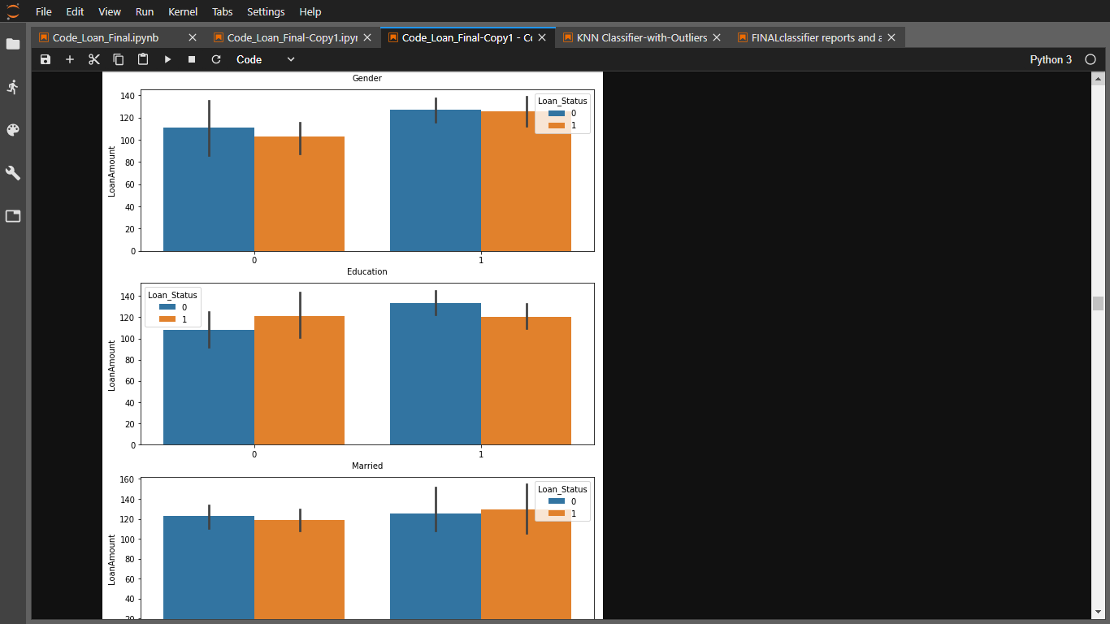

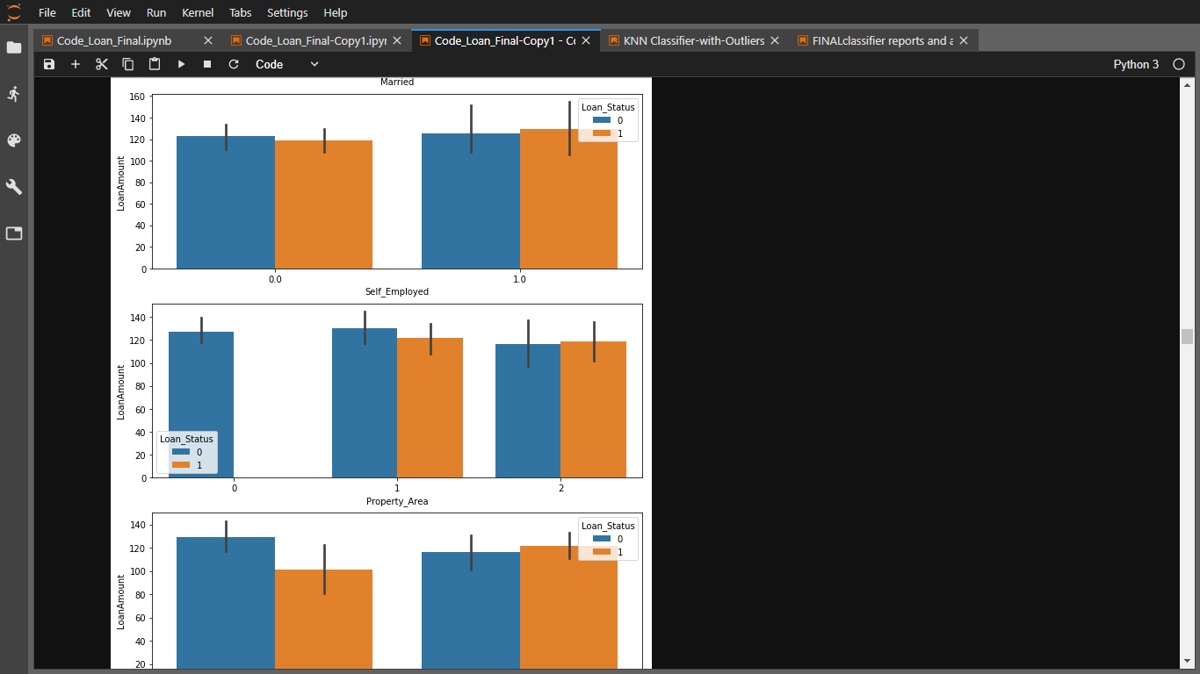

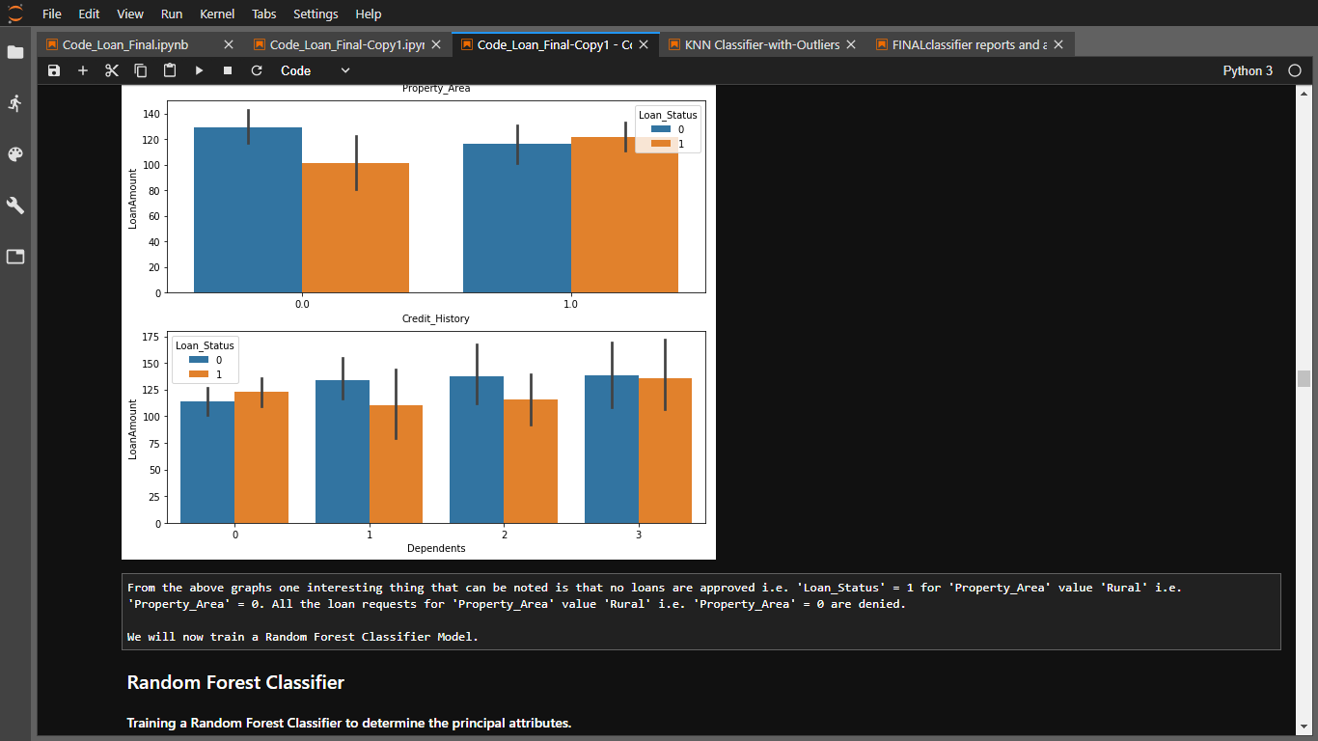

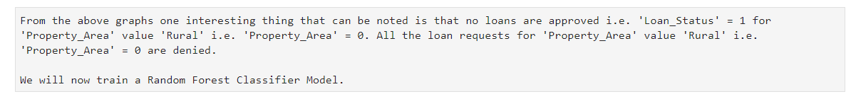

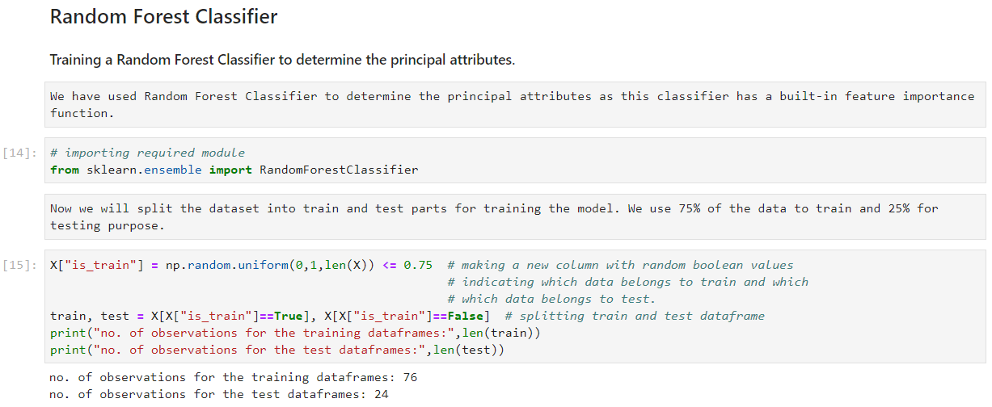

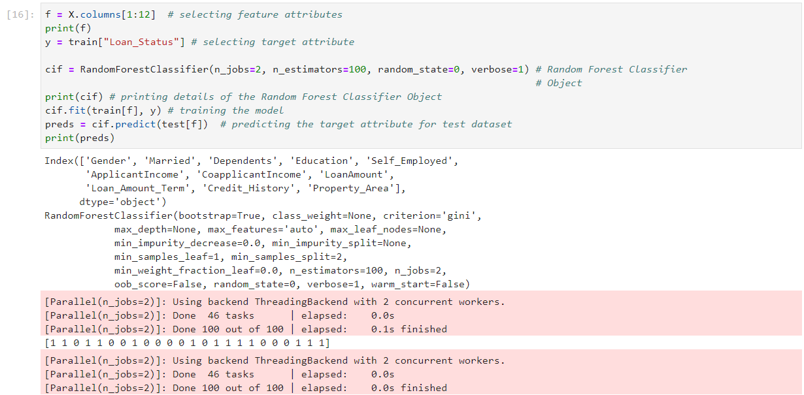

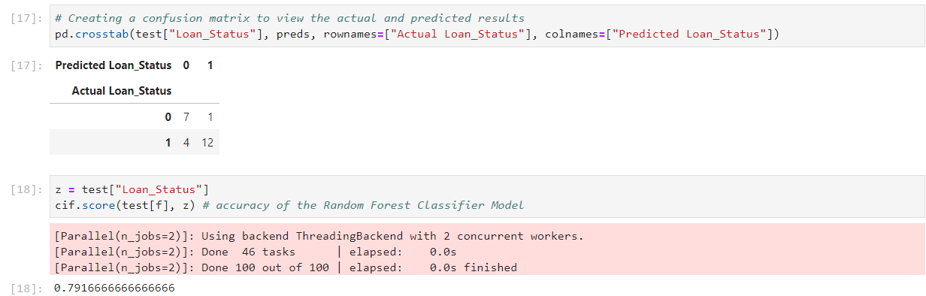

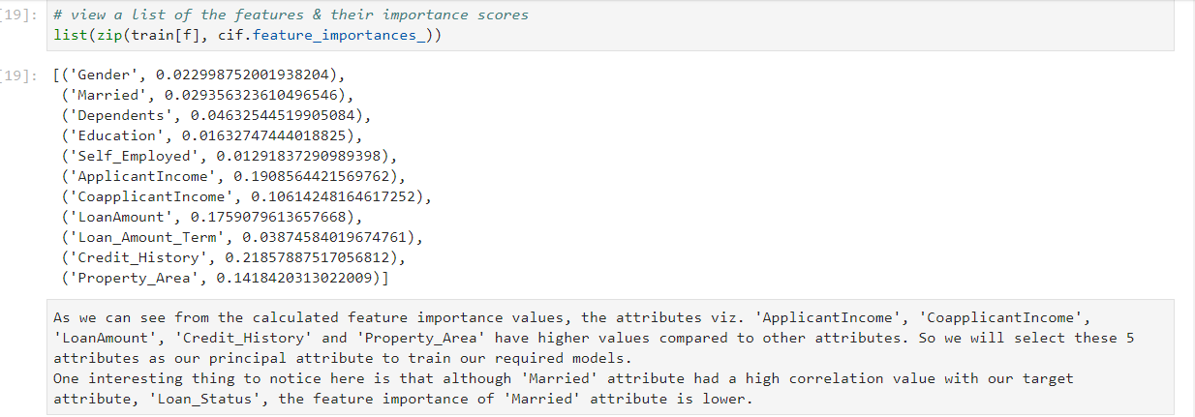

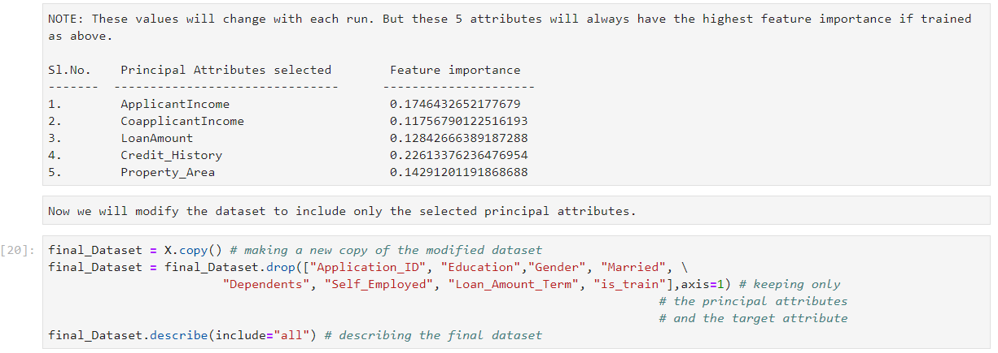

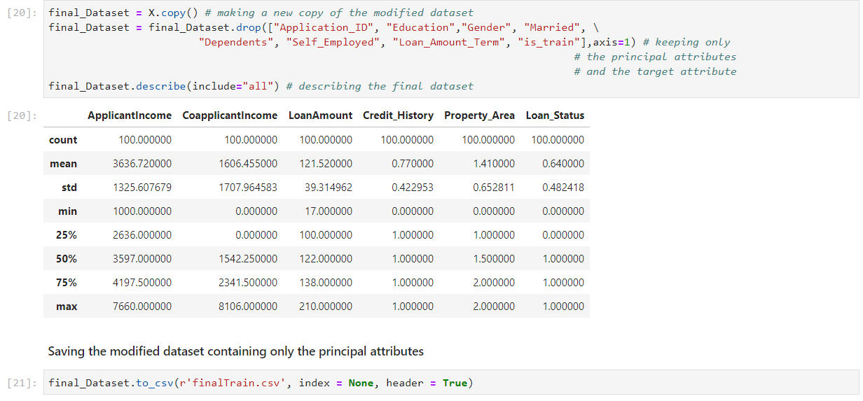

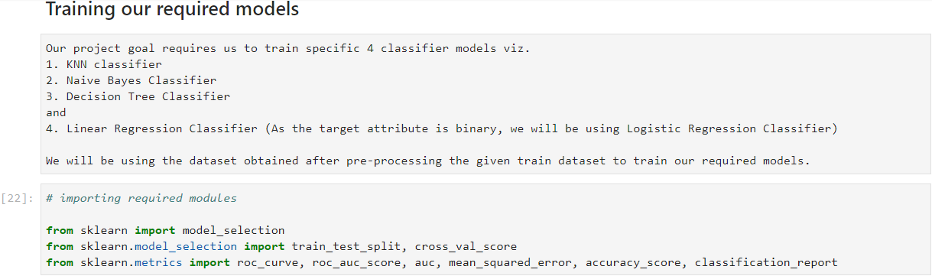

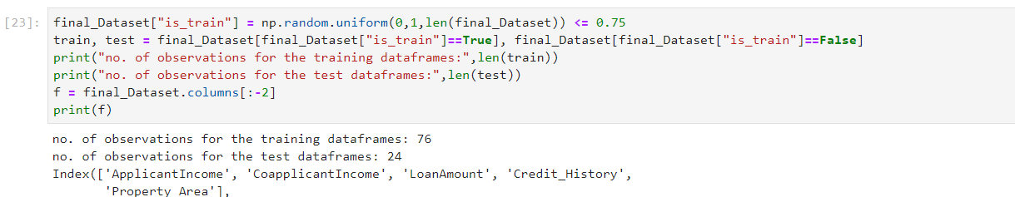

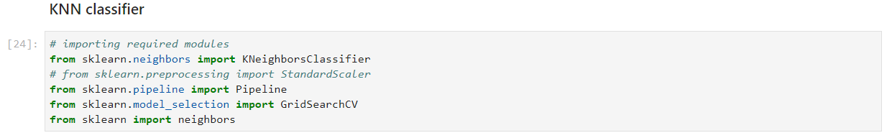

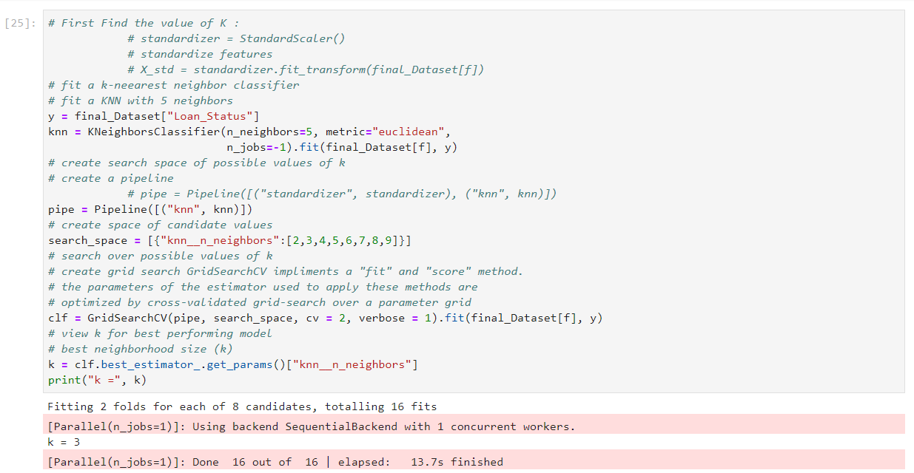

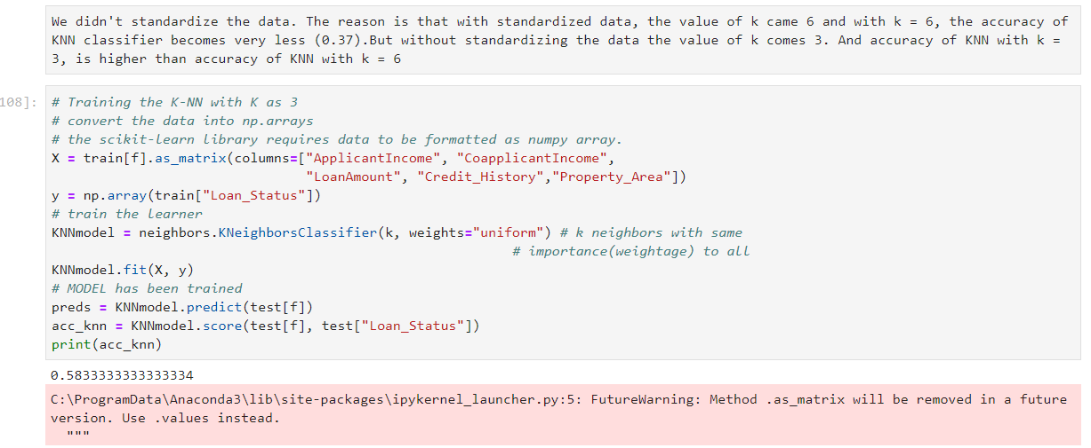

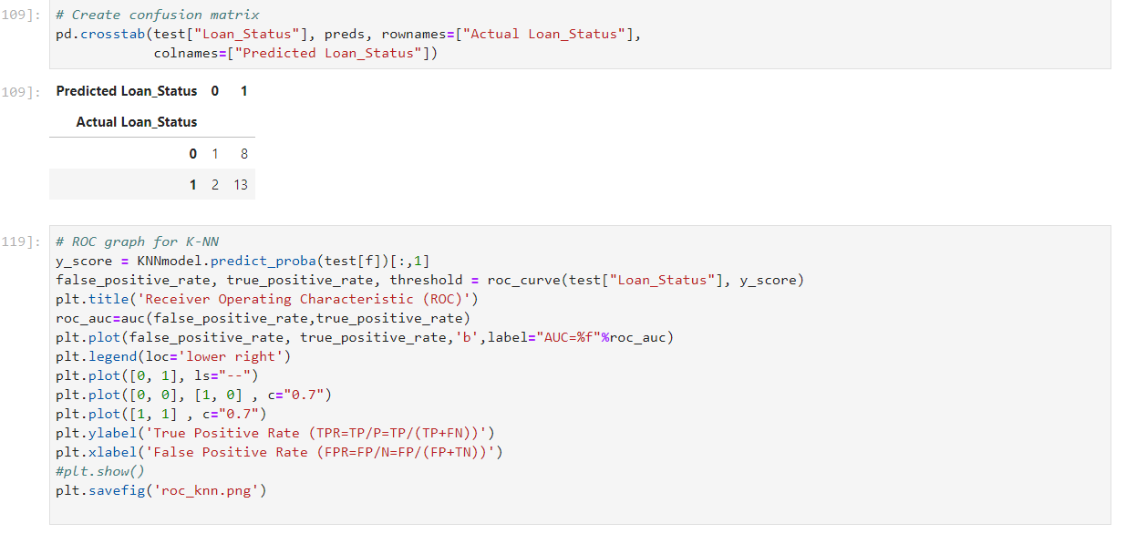

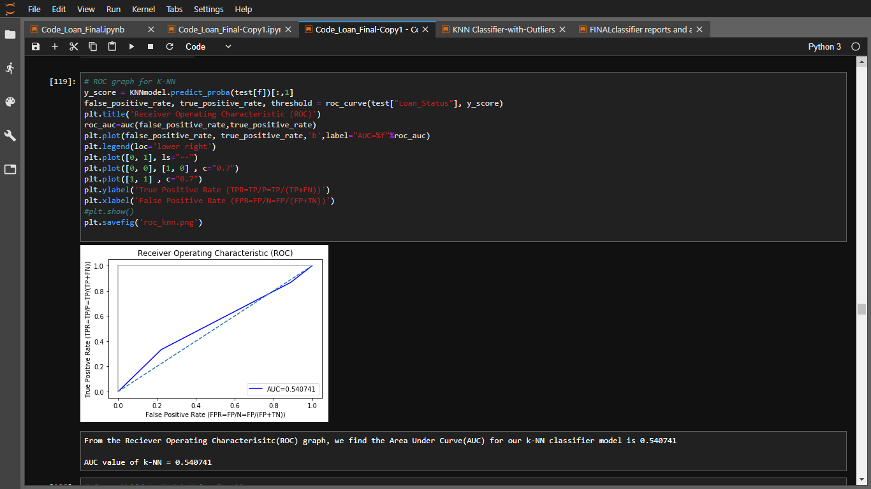

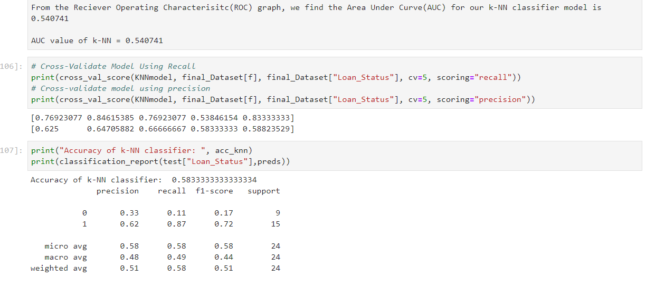

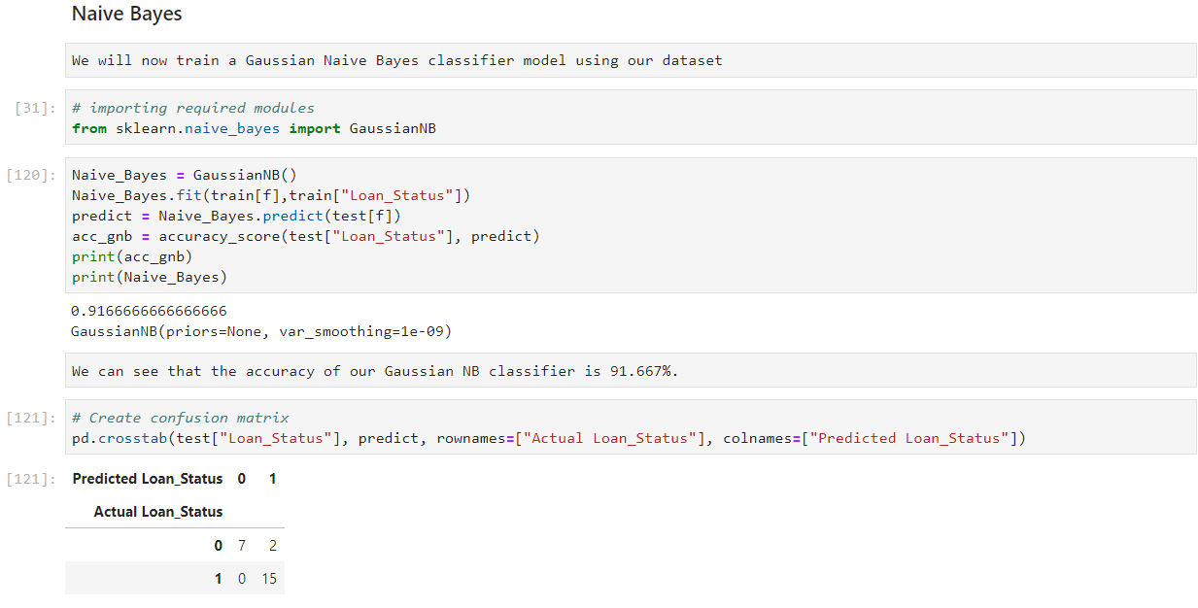

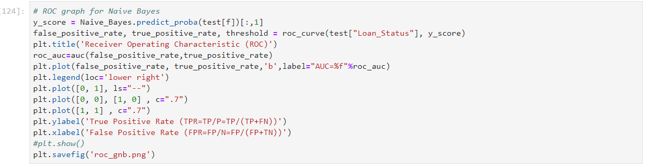

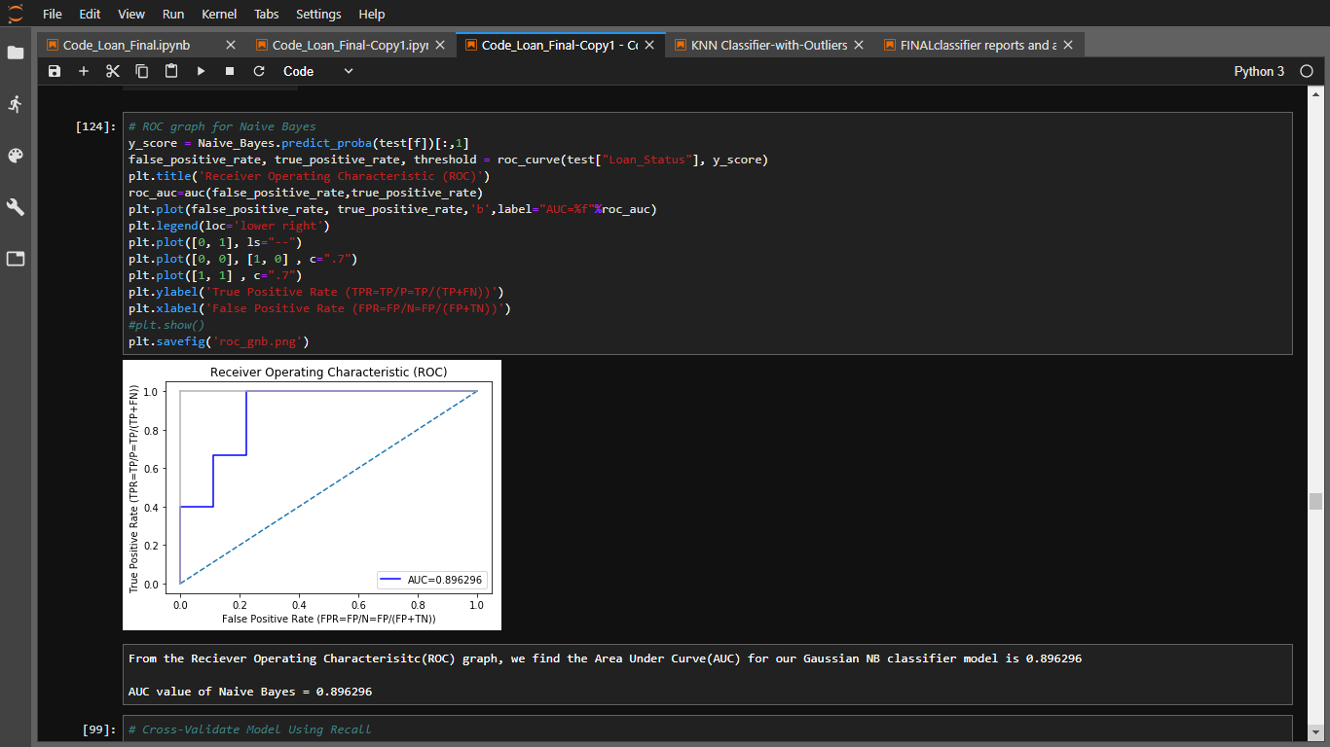

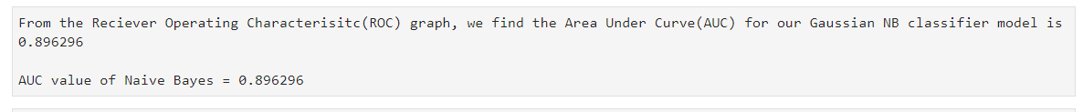

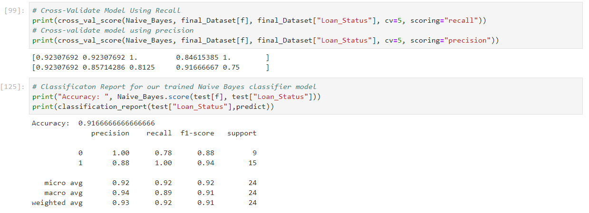

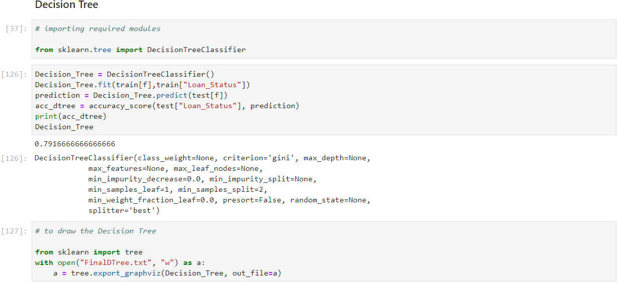

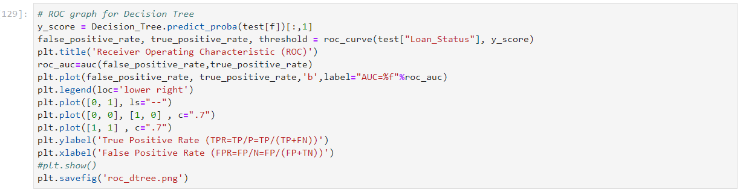

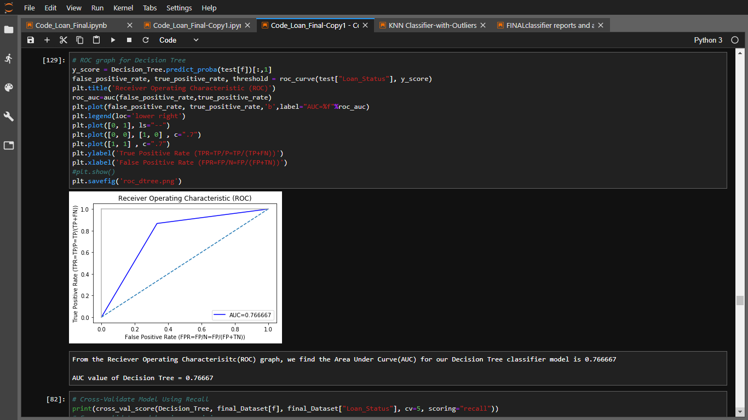

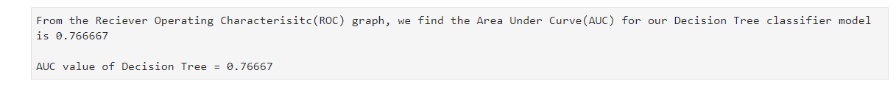

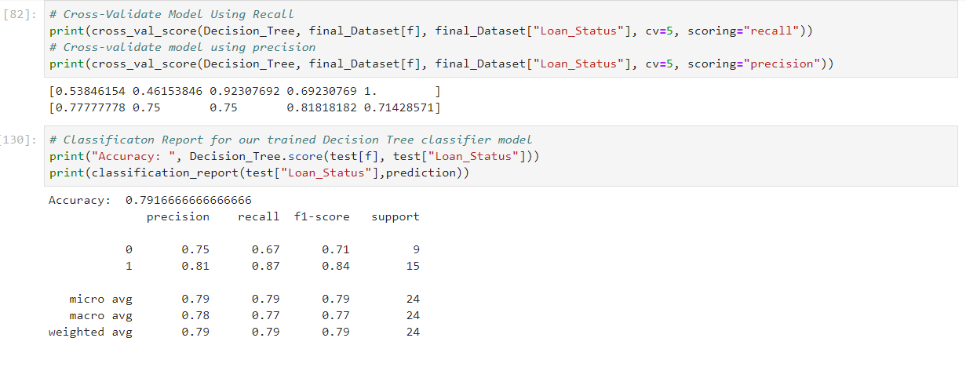

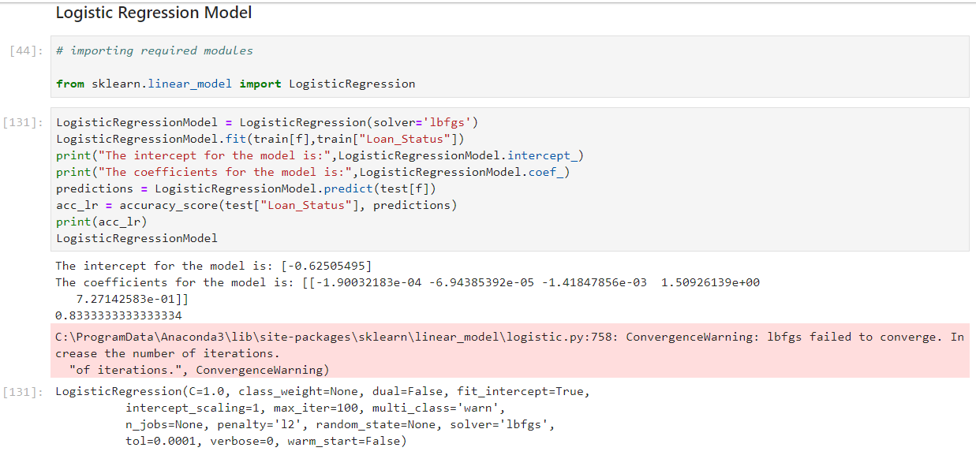

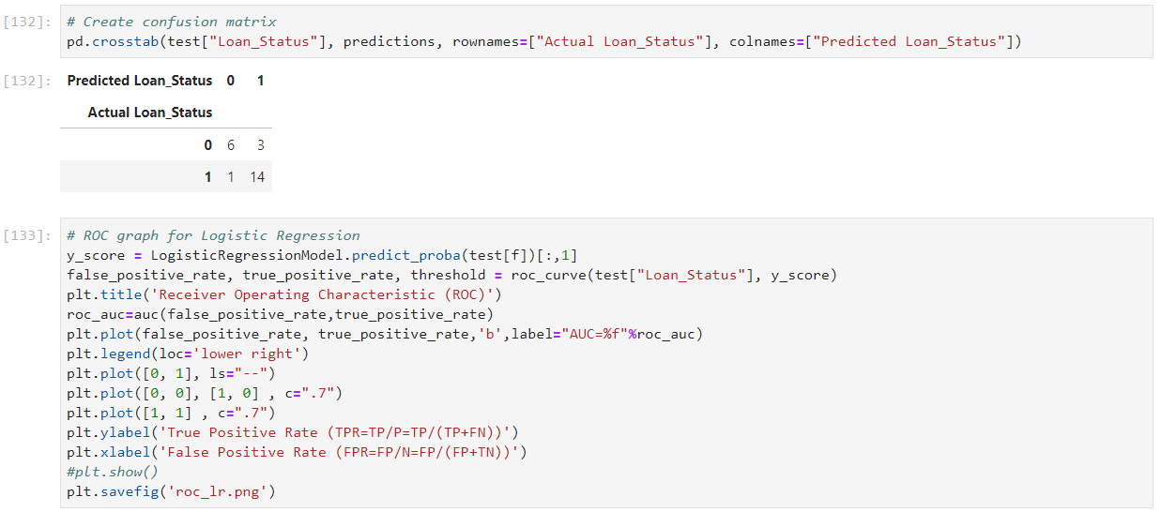

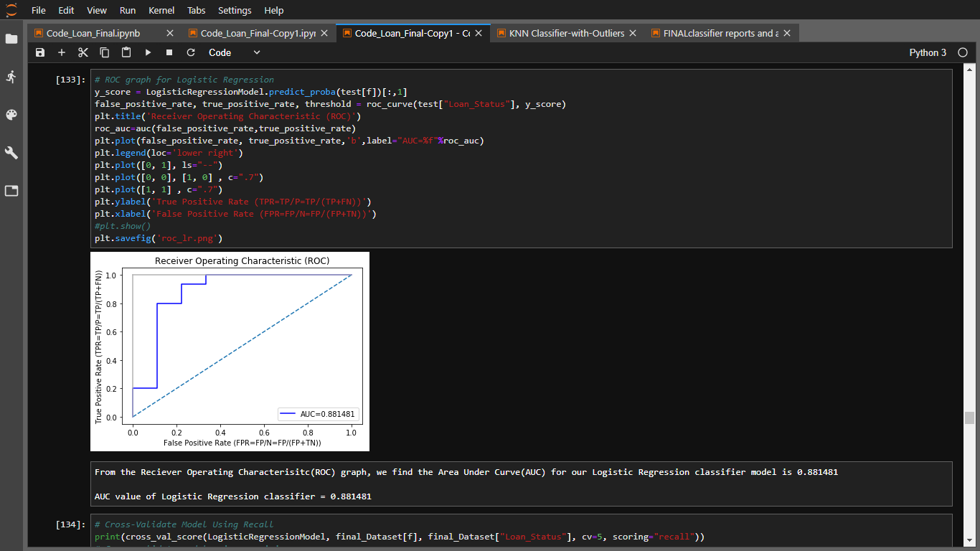

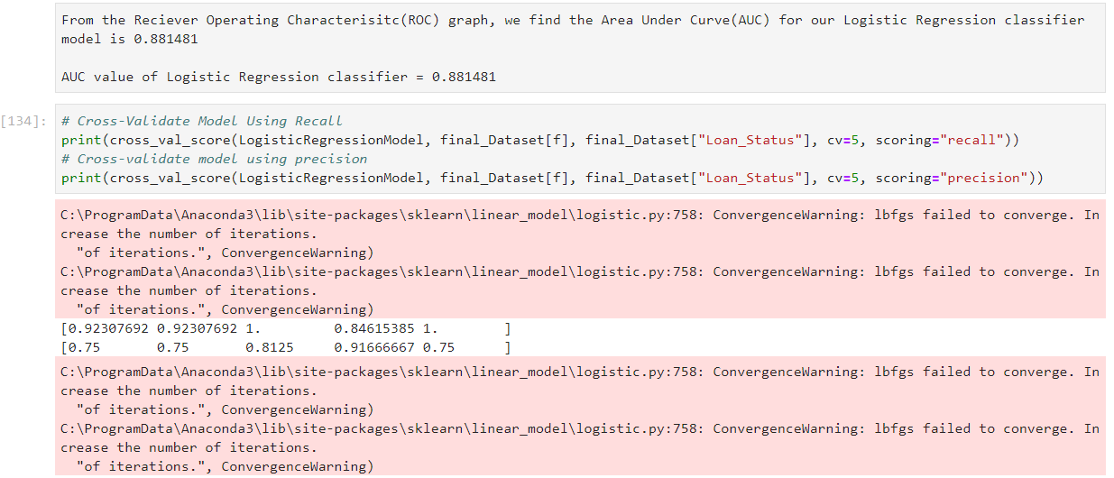

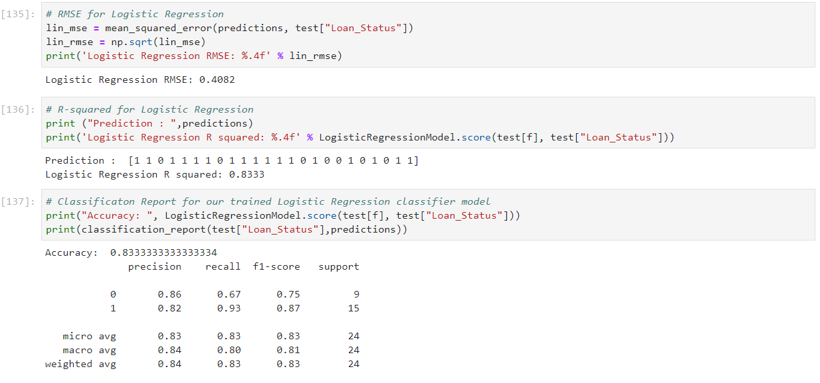

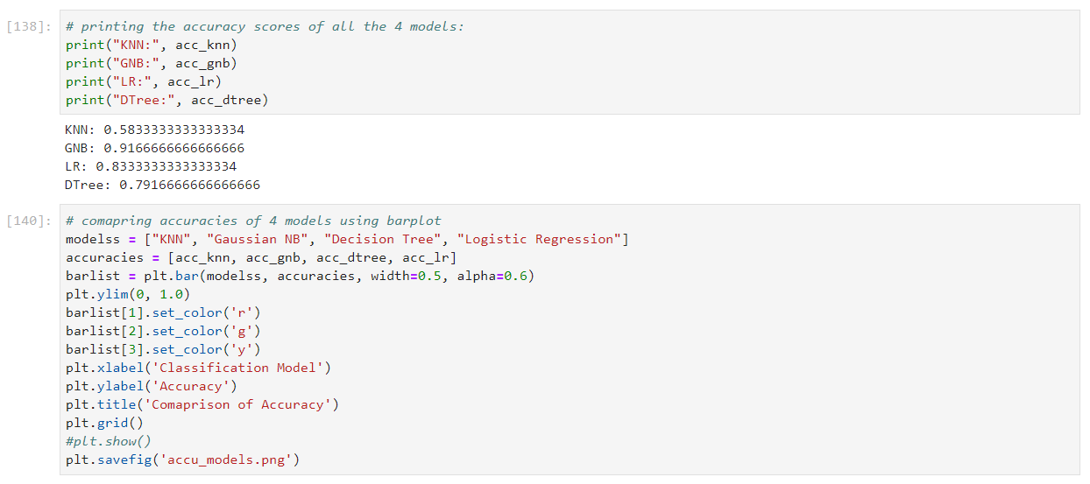

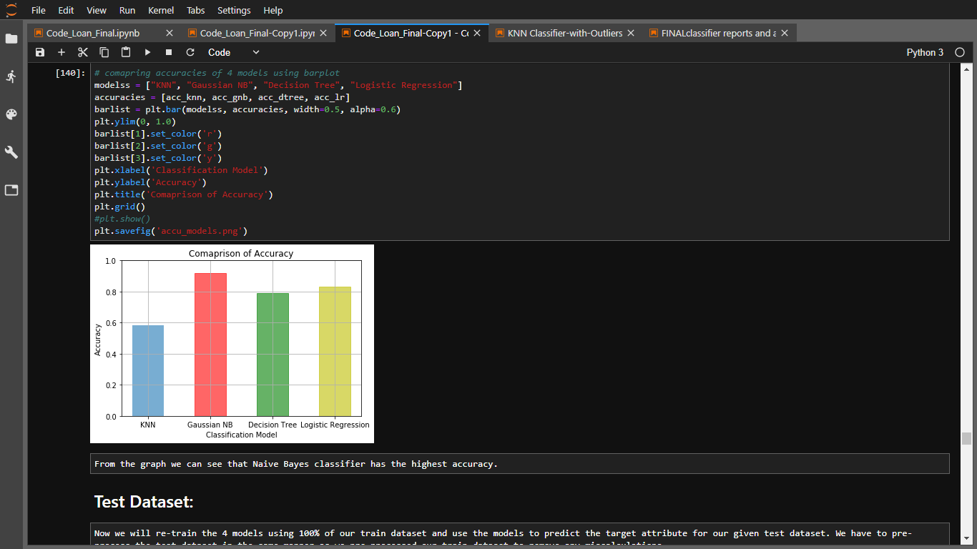

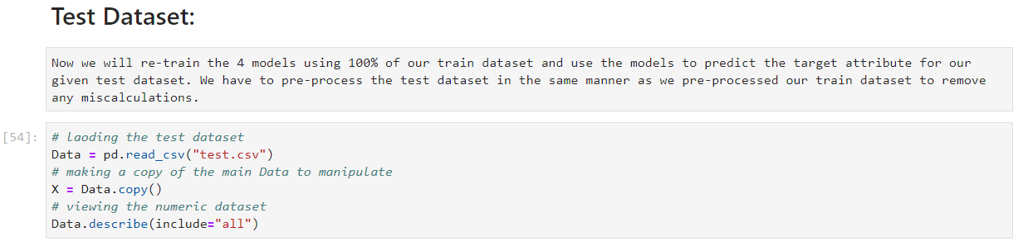

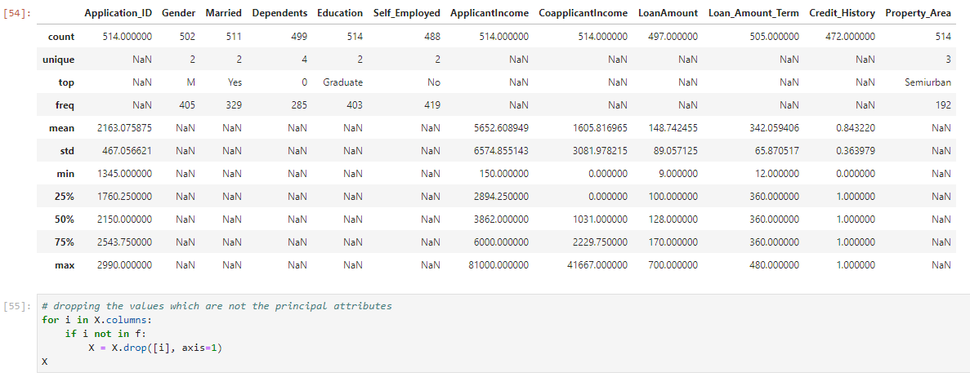



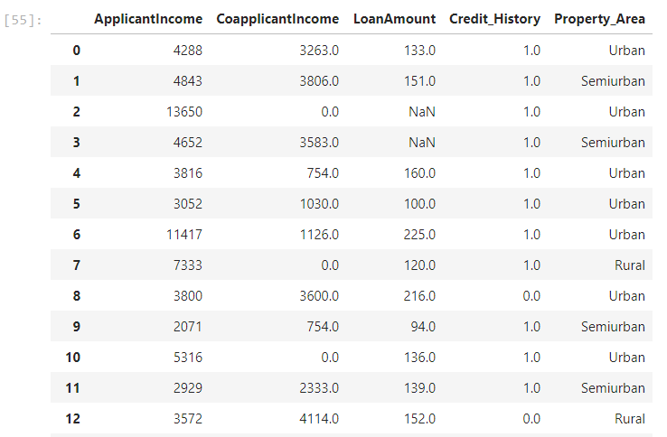

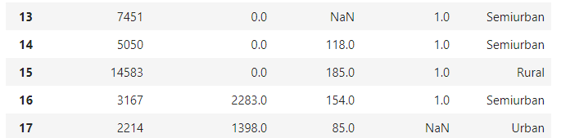

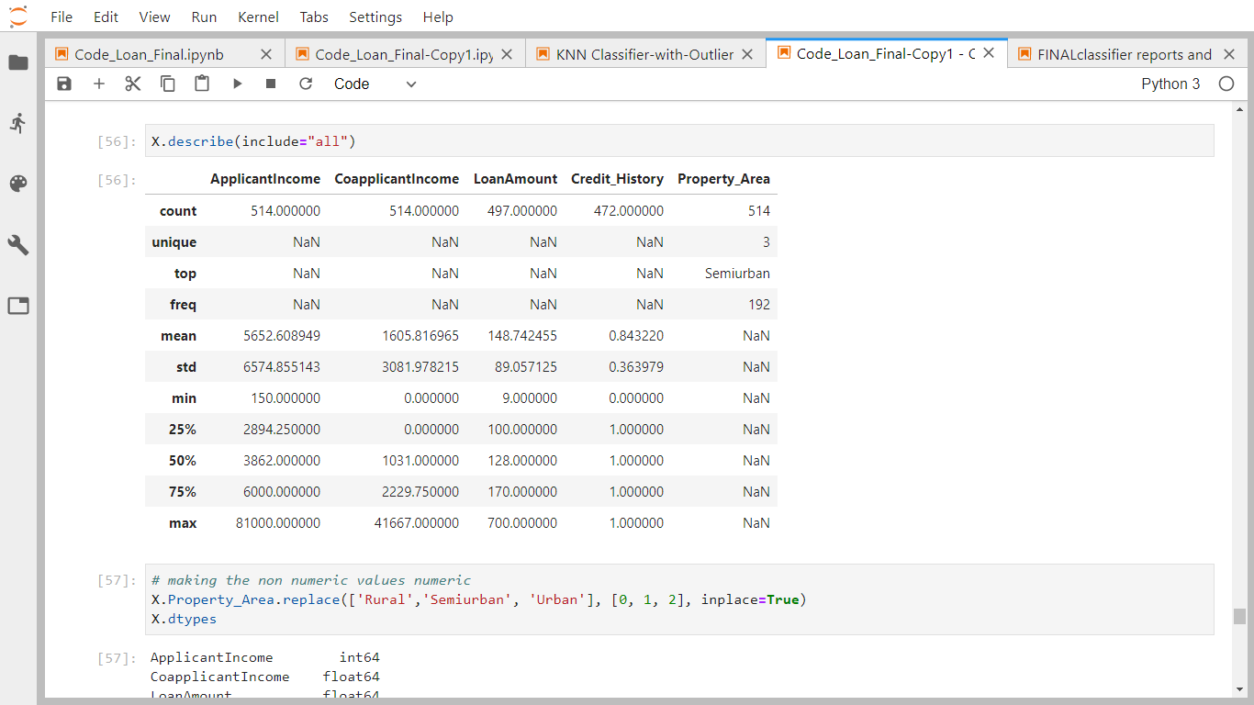

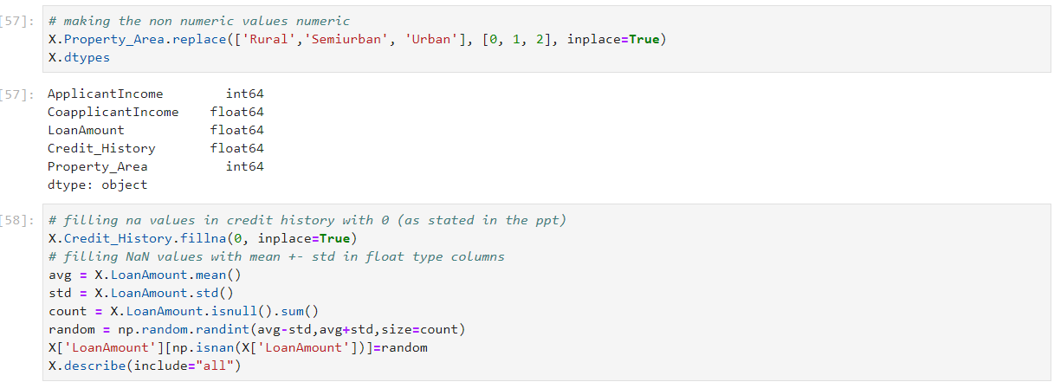

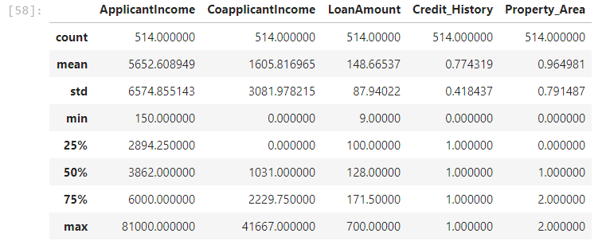

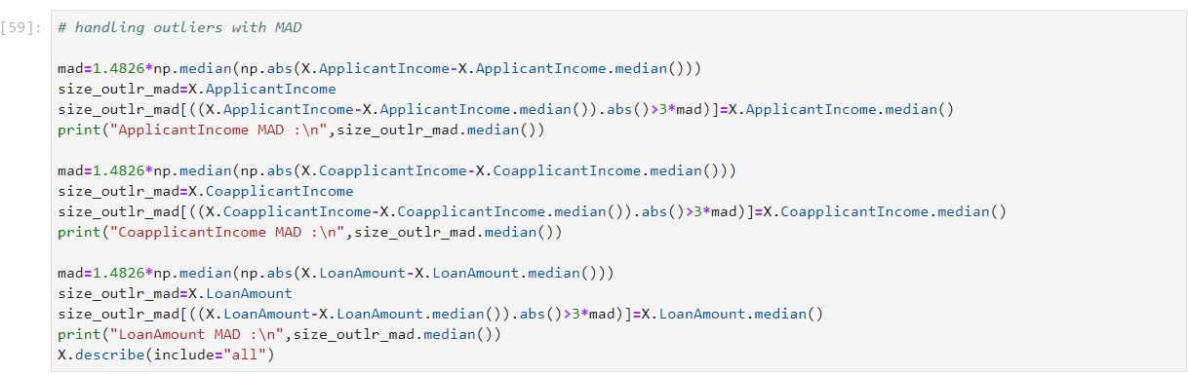

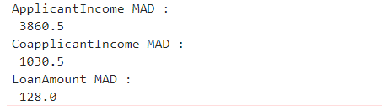

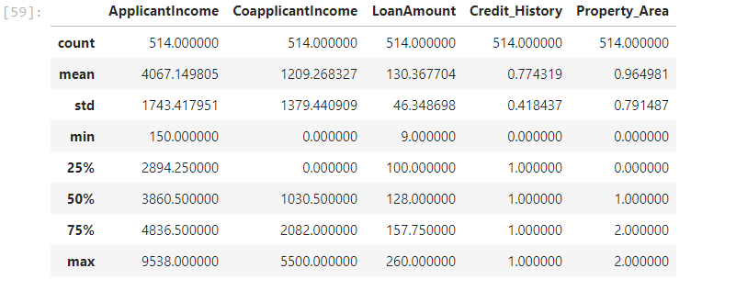

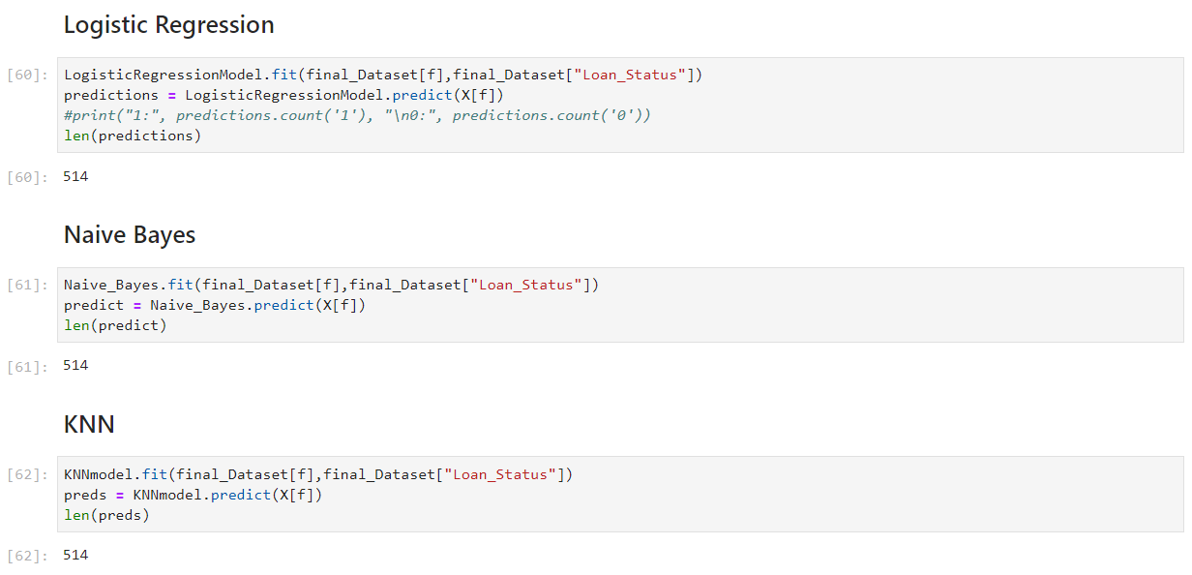

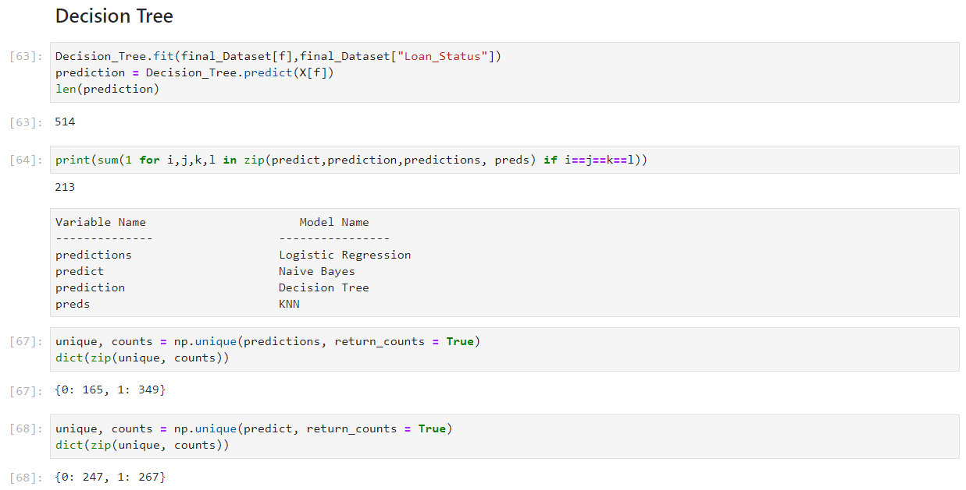

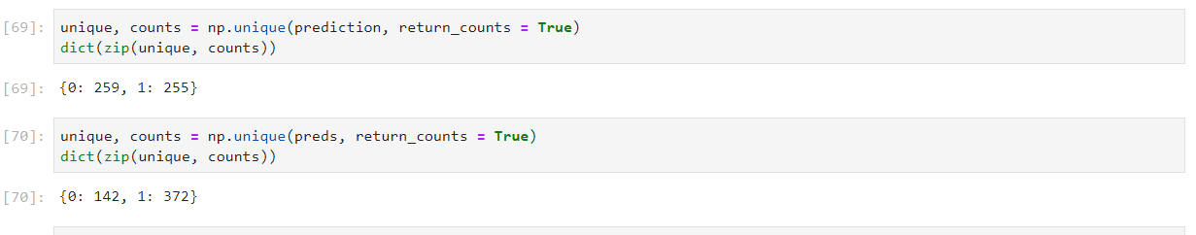

# Future Scope of Improvement

* Various banking institution can use these models and modify them according to their needs to use in their loan approval status. This will reduce the manual labour and time spent on determining whether to approve a loan application.
* Customers who intend to take a loan can use these trained models to check whether their loan application will be approved or not. The trained models would be required to be implemented in a platform or interface easily accessible as well as with an easy GUI.
* We saw a high value of correlation of "Married" attribute with our target attribute. But the feature importance of "Married" attribute was significantly lower. With more data and further analysis, it might be possible to describe the reason of this mismatch.
* No loan application having value "Rural" in "Property_Area" attribute was approved. With further research and more data for analysis, a more decisive conclusion can be made.

# Certificate

This is to certify that Mr. Debaleen Das Spandan of Bengal College of Engineering and Technology, registration number: 171250110041, has successfully completed a project on *Prediction of Loan Approval Status* using *Machine Learning with Python* under the guidance of Prof. Arnab Chakraborty.

--------------------------------------------------

Prof. Arnab Chakraborty

Globsyn Finishing School

# Certificate

This is to certify that Mr. Shouvit Pradhan of Bengal College of Engineering and Technology, registration number: 171250110093, has successfully completed a project on *Prediction of Loan Approval Status* using *Machine Learning with Python* under the guidance of Prof. Arnab Chakraborty.

--------------------------------------------------

Prof. Arnab Chakraborty

Globsyn Finishing School

# Certificate

This is to certify that Mr. Aditya Som Choudhury of Techno India Main Salt lake, registration number: 161300110620, has successfully completed a project on *Prediction of Loan Approval Status* using *Machine Learning with Python* under the guidance of Prof. Arnab Chakraborty.

--------------------------------------------------

Prof. Arnab Chakraborty

Globsyn Finishing School

# Certificate

This is to certify that Mr. Amartya Paul of BP Poddar Institute of Management and Technology, registration number: 161150110011, has successfully completed a project on *Prediction of Loan Approval Status* using *Machine Learning with Python* under the guidance of Prof. Arnab Chakraborty.

--------------------------------------------------

Prof. Arnab Chakraborty

Globsyn Finishing School

# Certificate

This is to certify that Mr. Palash Mondal of Techno India Saltlake, registration number: 181300120082, has successfully completed a project on *Prediction of Loan Approval Status* using *Machine Learning with Python* under the guidance of Prof. Arnab Chakraborty.

--------------------------------------------------

Prof. Arnab Chakraborty

Globsyn Finishing School